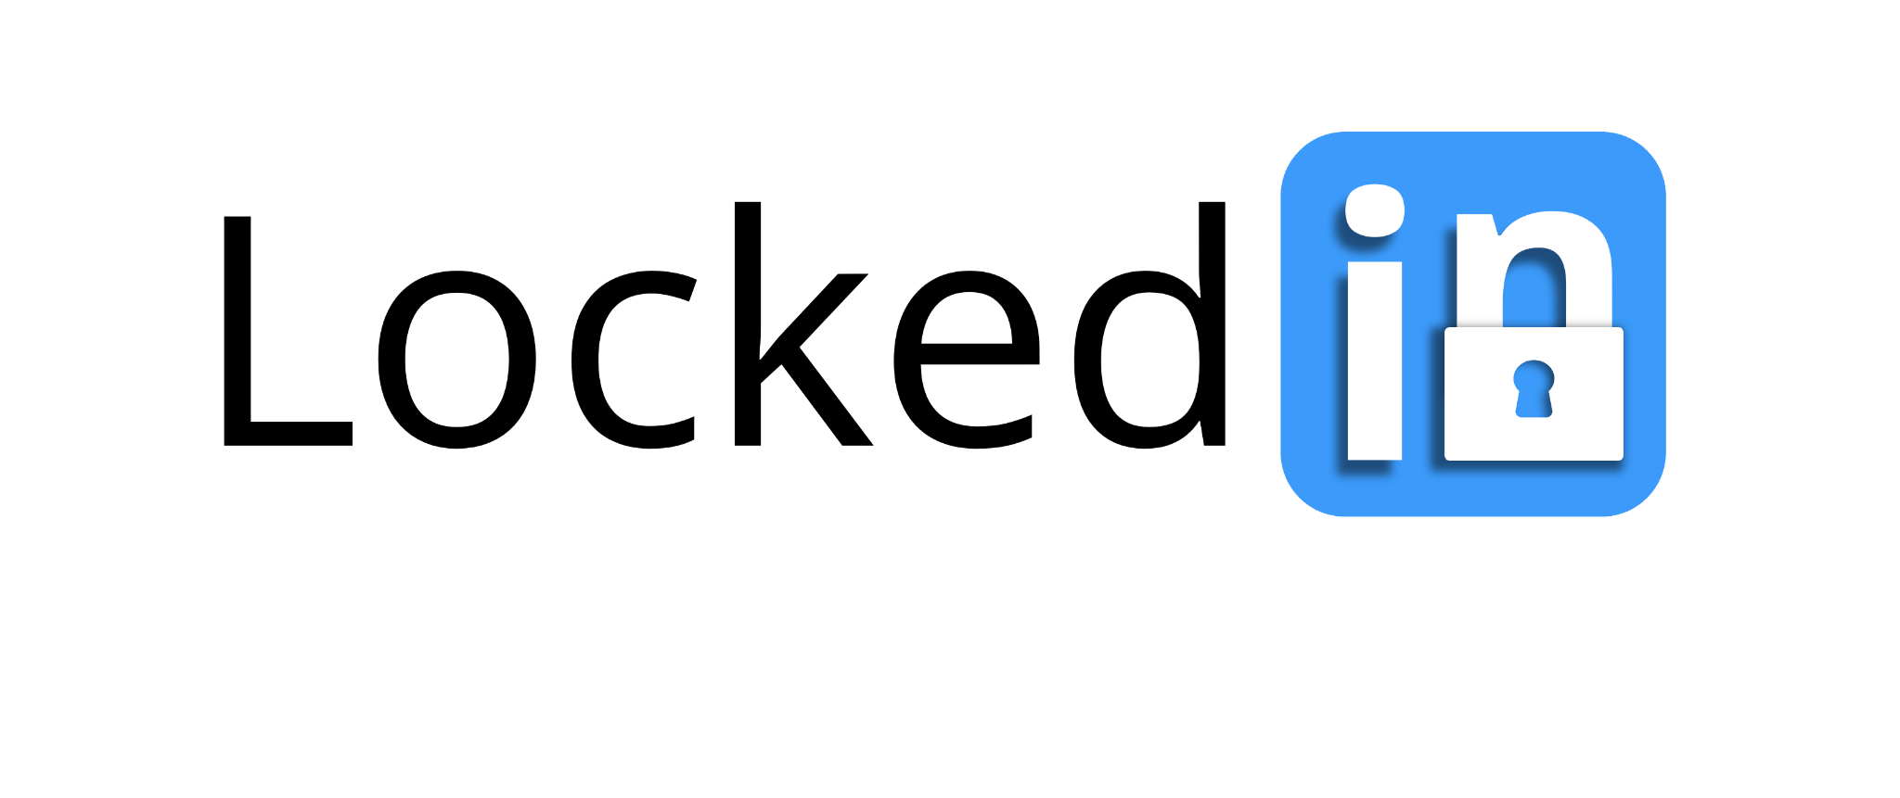

*Effortless, personalized study groups tailored to your schedule, preferences, and learning styles*

Final Report

CS147 Fall 2024

AI in the Classroom

Alexander Yue | Evan Hsu | Diego Valdez | Ecem Yilmazhaliloglu

**Table of Contents**

Page

| Project Name & Value Proposition | 2 |
| --- | --- |
| Team Member Names and Roles | 2 |
| Problem & Solution Overview | 3 |
| Needfinding | 4 |
| POVs & Experience Prototypes | 7 |
| Design Evolution | 15 |
| Final Prototype Implementation | 29 |
| Reflection & Next Steps | 32 |

**Project Name & Value Proposition**

**Project Name**

LockedIn

**Value Proposition**

Effortless, personalized study groups tailored to your schedule, preferences, and learning styles

**Team Member Names and Roles**

|  | *Sophomore, Physics*  Developer, Product Manager |
| --- | --- |

|  | *Coterm, Computer Science HCI*  Developer, UX/UI Designer |
| --- | --- |

|  | *Coterm, Computer Science HCI*  Developer, UX/UI Designer |
| --- | --- |

|  | *Senior, Computer Science*  Developer, Product Designer |
| --- | --- |

**Problem & Solution Overview**

**Problem Statement**

After conducting multiple needfinding interviews, our team found that students often face challenges when trying to connect with peers to collaborate. Social anxiety, differing schedules, and varying study habits can make it difficult for students to find and engage with others. In addition, organizing and managing class materials can be overwhelming, as it is common for students to manage multiple subjects, assignments, and deadlines.

**Our Solution**

Our app addresses these challenges by offering an intuitive platform that facilitates collaboration and classwork management. Students can upload their class materials and have our AI system organize them into clear, actionable tasks. These tasks can be manually customized and efficiently updated to suit user preferences. Additionally, our matching feature promotes effective and supportive study collaborations. By taking a study profile survey, students are matched with peers who have similar schedules and study habits. Our app also enables students to host public study sessions within their classes, promoting group study and collaboration.

**Needfinding**

**The Interviews**

Our target domain was college students, and we conducted a total of 6 interviews across two rounds of needfinding. For interviewee sourcing, each team member tapped into their personal networks,including friends of friends. Some interviews required traveling off campus, with one trip to UC Berkeley. We offered compensation as incentive for interviewees who were less familiar with us. Each interview was conducted by two team members- one acting as the interviewer and the other as the notetaker.

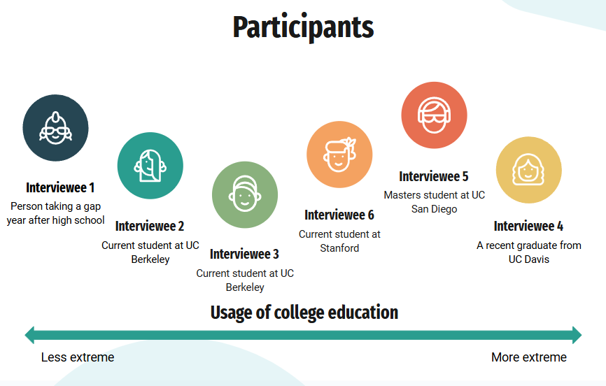

Figure 1 - Distribution of interviewees on a scale from less to more extreme based on their usage of college education

Our questioning process focused on three key areas:

1. **Learn about their identity** - We asked questions such as “What do you study” and “What are your academic goals and interests?” to better understand the backgrounds of each interviewee.
2. **Discover pain points** - We asked questions such as “What difficulties do you encounter when studying?” and “How do you currently manage your schoolwork?” to explore the challenges that they might face.
3. **Explore their behaviors** - We asked questions such as “What tools do you use to stay on top of your assignments?” and “In the case where you experienced difficulty in collaborating with others, what did you do instead?” to understand their current approach to addressing their pain points.

Interviewee details are listed below:

1. Gap year student, 2 years of public high school, 2 years of IB (extreme user)
2. Sophomore at UC Berkeley, public health major, pre-med, researcher at UCSF
3. Sophomore at UC Berkeley, public health major, pre-med, works in the Essig Museum of Entomology
4. Recent graduate from UC Davis, BS in Environmental Science and Management, minor in Environmental Policy Analysis and Planning
5. Masters student at UCSD, electrical engineering major, lives off-campus
6. Masters student in Community Health and Prevention Research at Stanford, pre-med

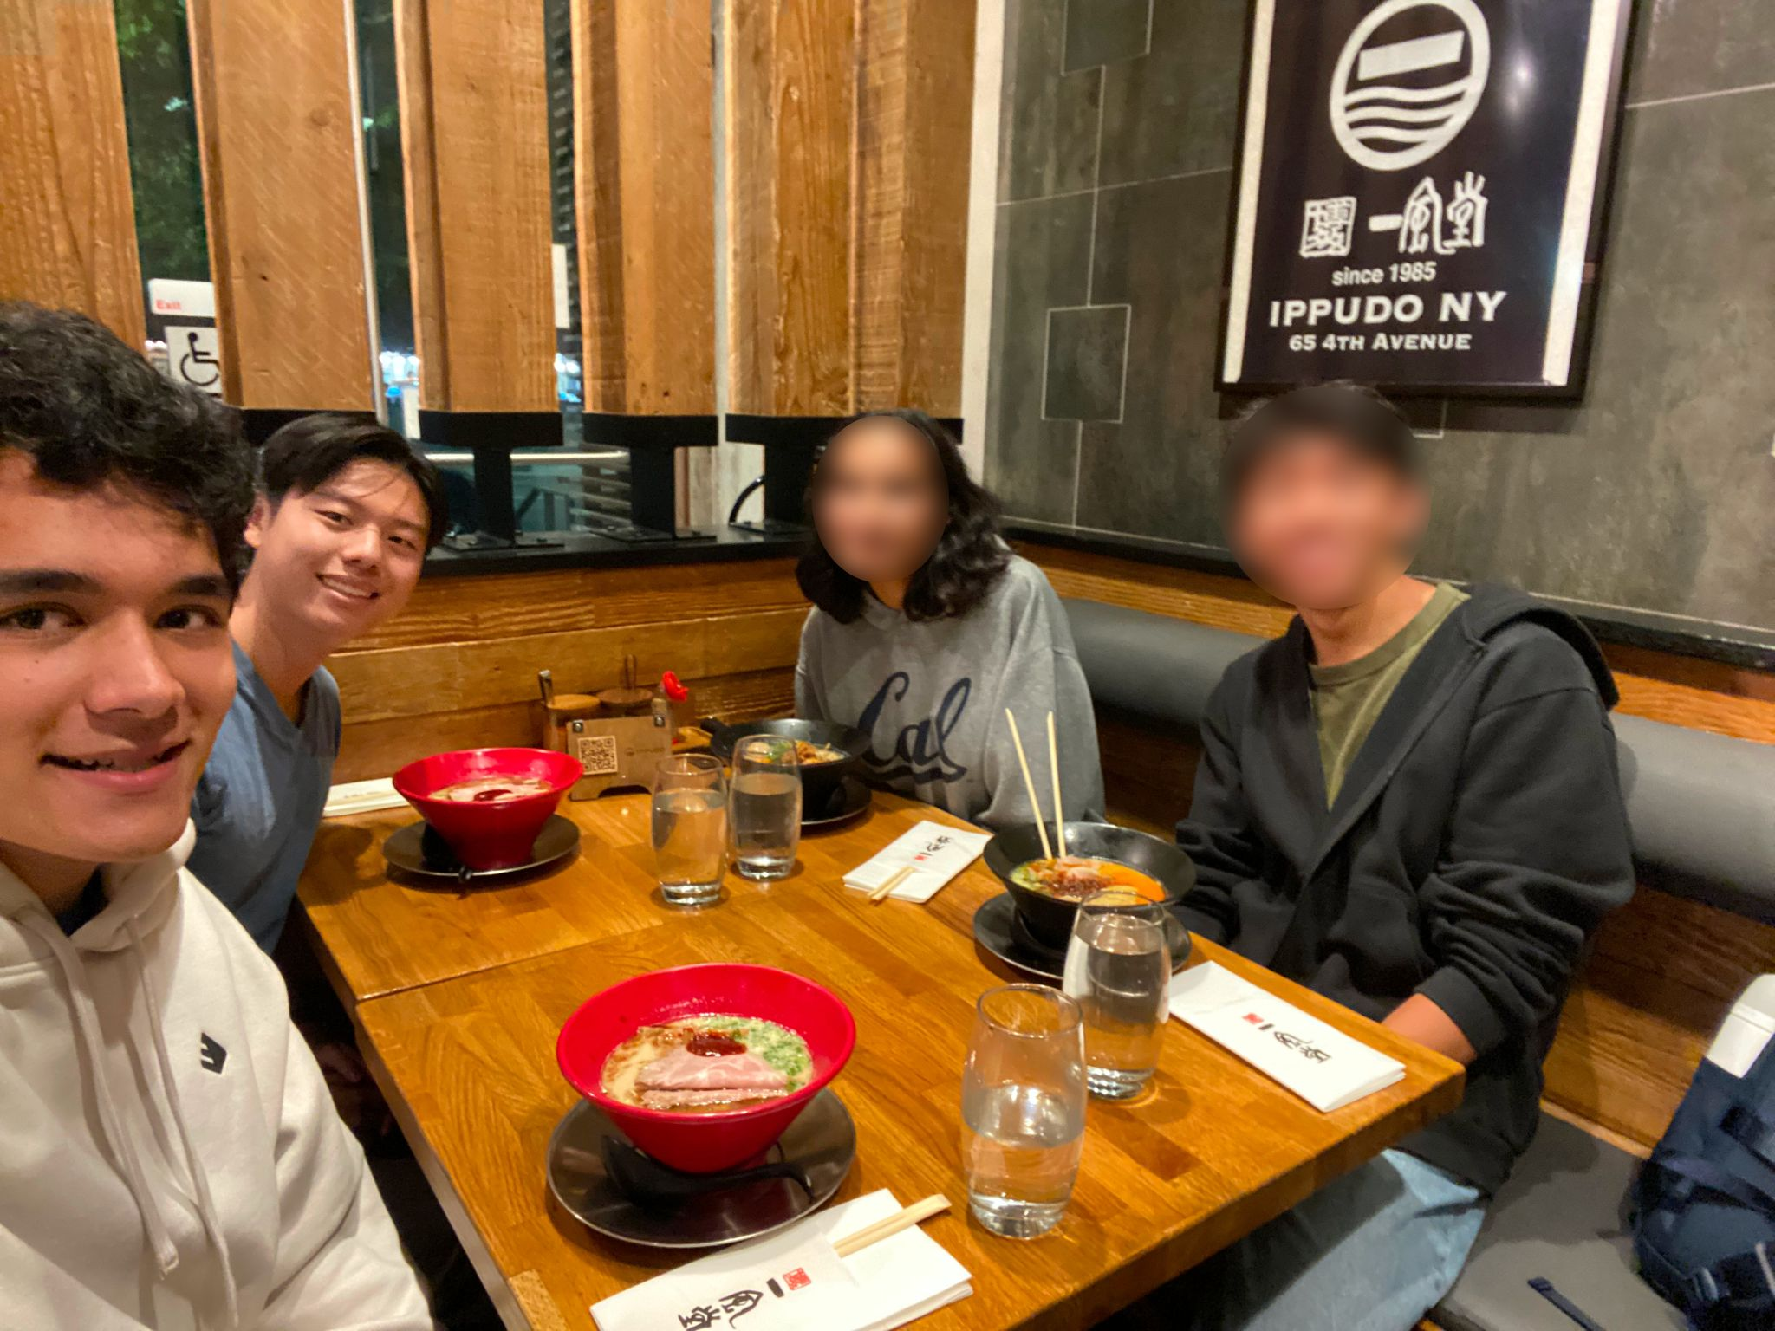

Figure 2 - Selected photos from needfinding interviews 2,3, and 4

**Result Synthesis**

Our needfinding interviews provided critical insights into the key challenges faced by students. To analyze the data from our interviews, we created an empathy map for each interviewee, writing notes on what each person says, thinks, does, and feels. We also compiled important quotes from each interview to highlight key themes and perspectives.

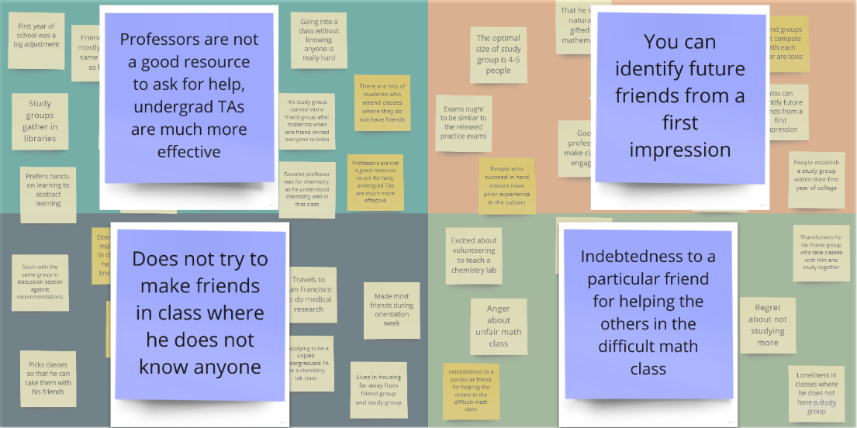

Figure 3 - An empathy map from interview 3

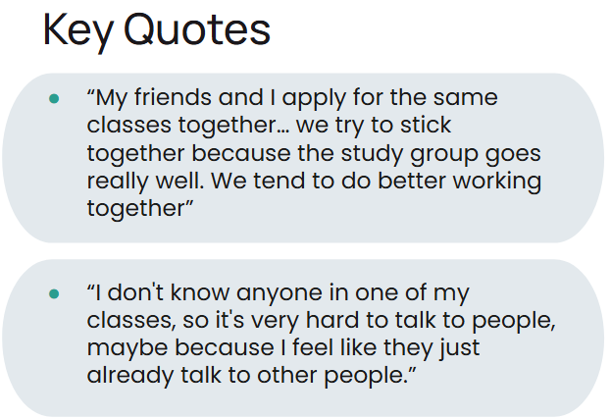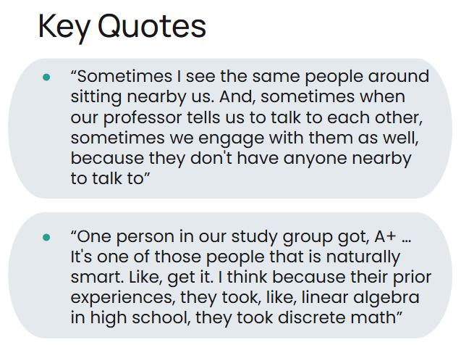

Figure 4 - Selected key quotes from our interviews

Following our interviews, we arrived at these takeaways:

* Connecting with other students to collaborate or share resources can be challenging
* There are personal barriers to peer collaboration
* Engagement is key to learning

**POVs & Experience Prototypes**

In our next steps, we reviewed the empathy maps from each interview and selected the three most valuable interviews to analyze further. We decided to craft a POV statement for interviewees 1, 3, and 4. These statements outline who our interviewees are and allow us to establish topics for brainstorming. For each of our POVs, we generated 10 How Might We (HMW) statements to guide the development of solutions.

a. Your final 1-3 POV statements b. A sampling of the HMWs that stemmed from each POV c. Top 3 solutions from brainstorming d. Brief description of each experience prototype: i. The assumption being tested ii. Key aspects of the prototype setup iii. What worked/didn't work, implications

**Final POVs and HMW Samples**

**Interviewee #1**

Details:

* gap year student
* 2 years of public high school
* 2 years of IB
* Our extreme user

POV

*We met*

“Jane,” a highschool graduate taking a **gap year** to reapply to college, who feels she hasn’t been supported enough during the college applications process.

*We were surprised to notice*

She believes guidance from others would have helped her with college applications, but **doesn’t know how to reach out to** others for feedback.

*We wonder if this means*

The **anxiety** of opening up to other students about her application is causing her to fall behind

*It would be game-changing if*

Students had **assistance** in sharing their application experiences and tips.

We brainstormed HMW statements together in a 5 minute time period for interviewee #1

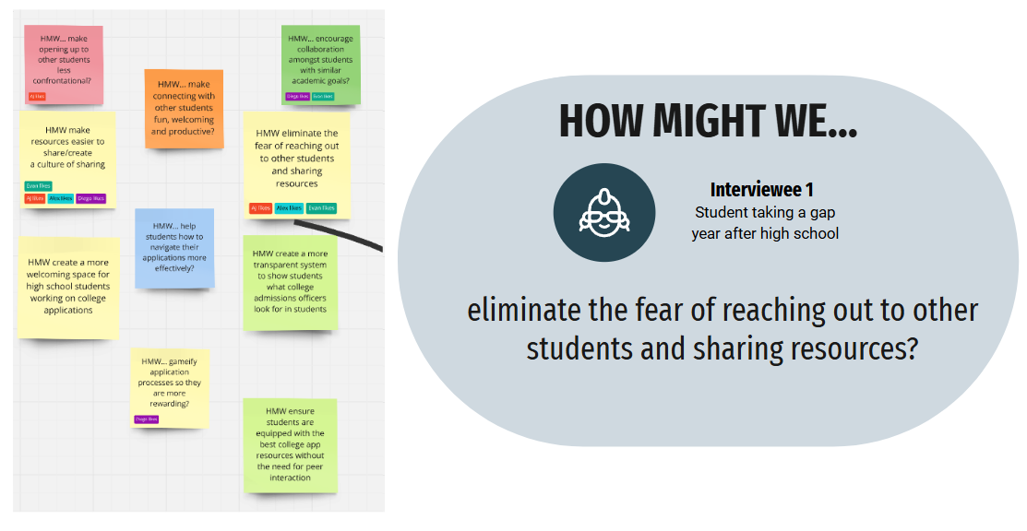

Figure 5 - HMWs for Interview #1 and a highlight of our favorite HMW

**Interviewee #3**

Details:

* Sophomore at UC Berkeley
* Public health major
* Pre-med
* Works in the Essig Museum of Entomology

POV

*We met*

“Gavin,” a hardworking pre-med student at UC Berkeley who feels he has **less prior academic experience** than many others.

*We were surprised to notice*

The **awkwardness** of meeting new people is preventing him from reaching his **academic goals**.

*We wonder if this means*

The **anxiety** of opening up to other students about her application is causing her to fall behind

*It would be game-changing if*

Students felt **comfortable** working with each other in every class.

We brainstormed HMW statements together in a 5 minute time period for interviewee #3

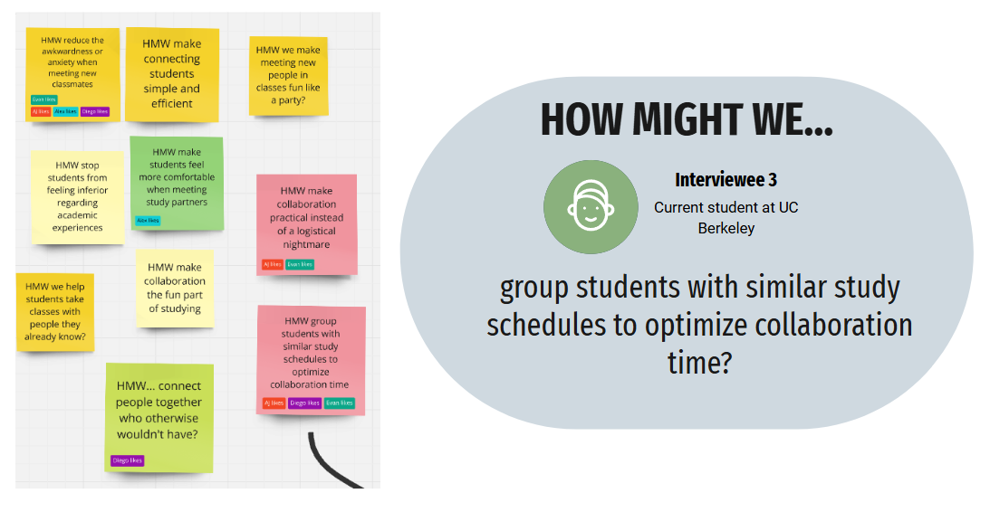

Figure 6 - HMWs for Interview #3 and a highlight of our favorite HMW

**Interviewee #4**

Details:

* Recent graduate from UC Davis
* BS in Environmental Science and Management
* Minor in Environmental Policy Analysis and Planning

POV

*We met*

"Sofia," a recent Environmental Science **graduate** from UC Davis, who often felt **overwhelmed** by the pressures of navigating both her academic and career journey.

*We were surprised to notice*

Despite expressing difficulty in **finding resources** for classes and internships, Sofia was able to name a few that she successfully utilized.

*We wonder if this means*

The issue may not be an overall lack of resources, but that the resources don’t translate into **clear, personalized support** for students.

*It would be game-changing if*

Students could **confidently** navigate their academic & career paths utilizing personalized available resources.

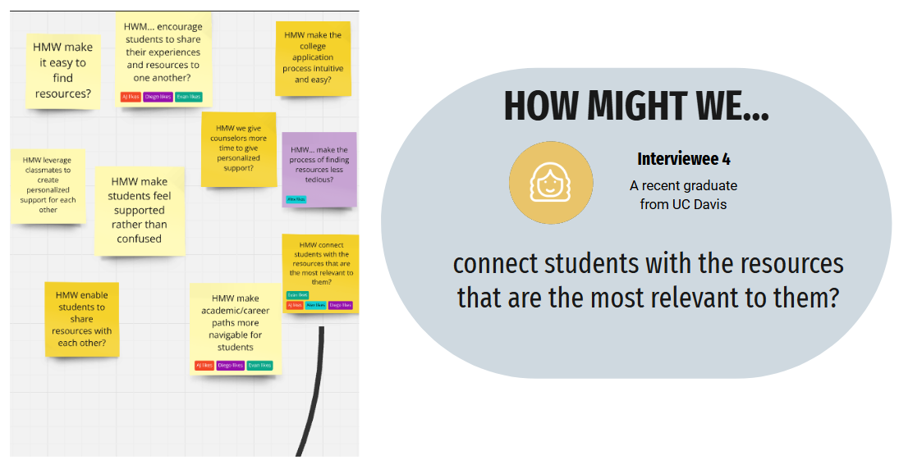

Figure 7 - HMWs for Interview #4 and a highlight of our favorite HMW

**Top 3 Solutions from Brainstorming**

After brainstorming our HMWs, we formulated a solution for each HMW statement that we highlighted from each interview.

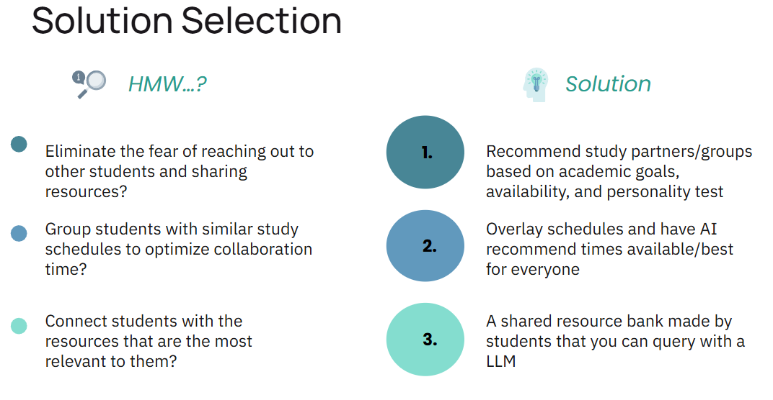

Figure 8 - HMW and solution selection side-by-side view

**Experience Prototypes**

| ***Solution*** | ***Assumption*** |
| --- | --- |
| Recommend study partners/groups based on academic goals, availability, and personality test | People are open to making a school profile and be matched to other students |
| Overlay schedules and have AI recommend times available/best for everyone | People know and can share their study availability in advance |
| A shared resource bank made by students that you can query with a LLM | People want to ask study app or resource questions to a LLM |

**Experience Prototype #1**

***Assumption*** - People are open to making a school profile and be matched to other students

**Description:** We created a questionnaire that asks about study habits, personality and class expectations to determine the “fit” between potential study partners

**Props:** We created a physical “profile worksheet” containing questions relevant to studying habits and characteristics. Discussions took place after completion.

**Participants & Relevance:** The participants were all Stanford students, mostly undergraduates under the engineering school. They were recruited through warm contacts.

**Method:** A person was asked to thoughtfully fill out the profile worksheet, and asked if they would be willing to form a study group with other participants, judging by their previously filled profiles.

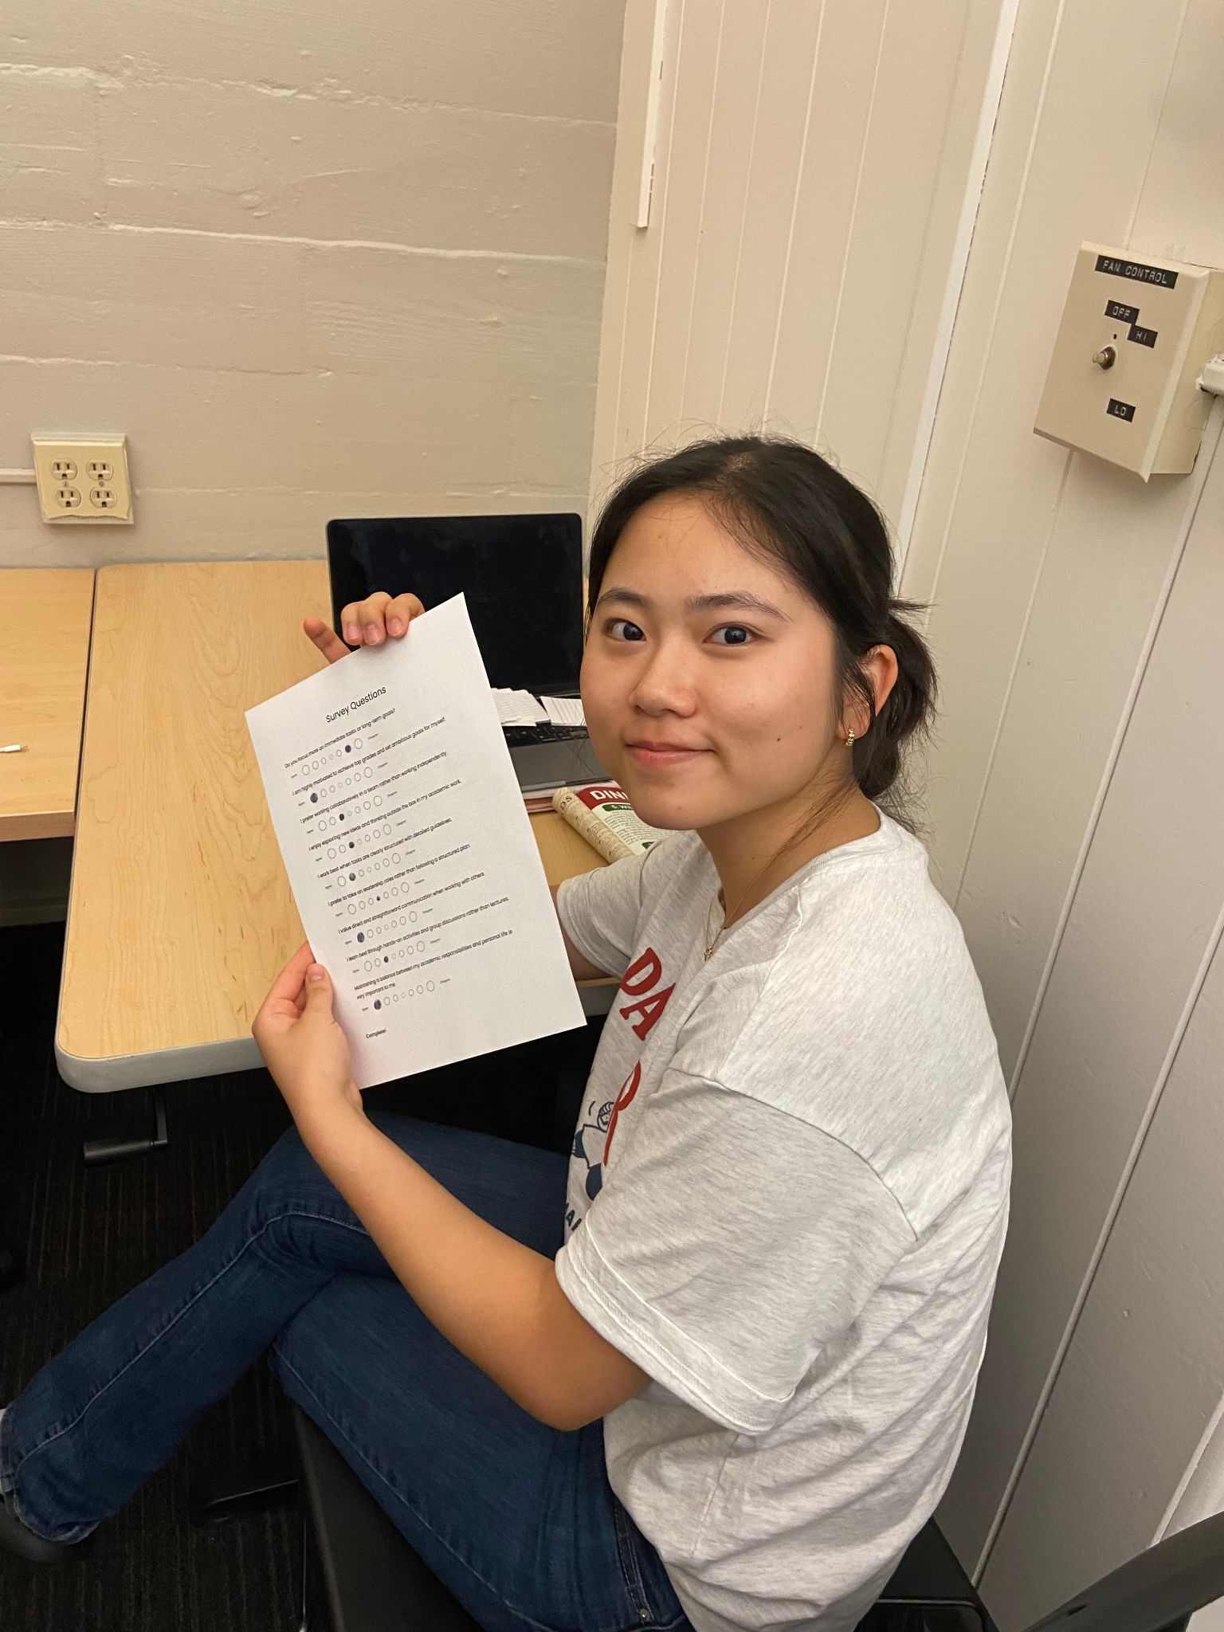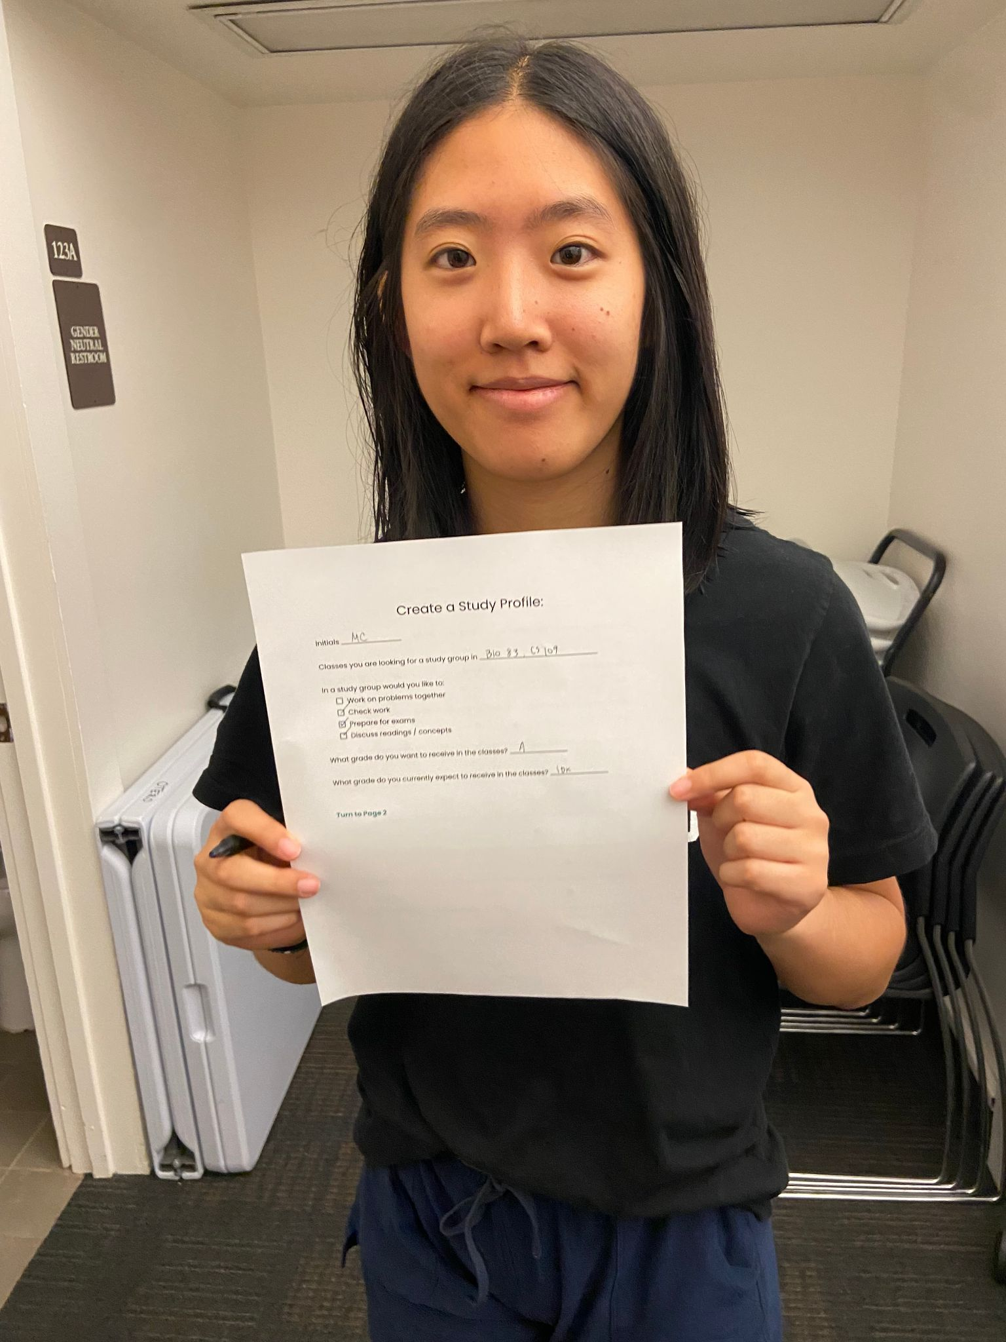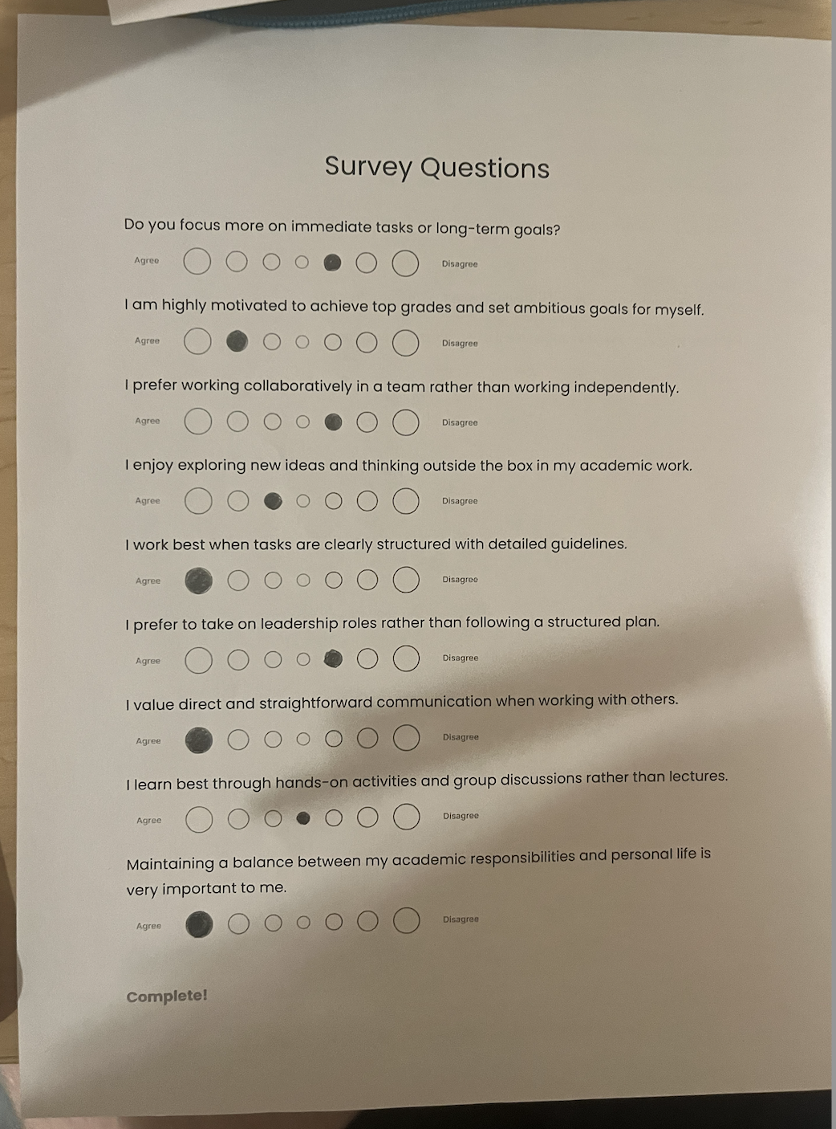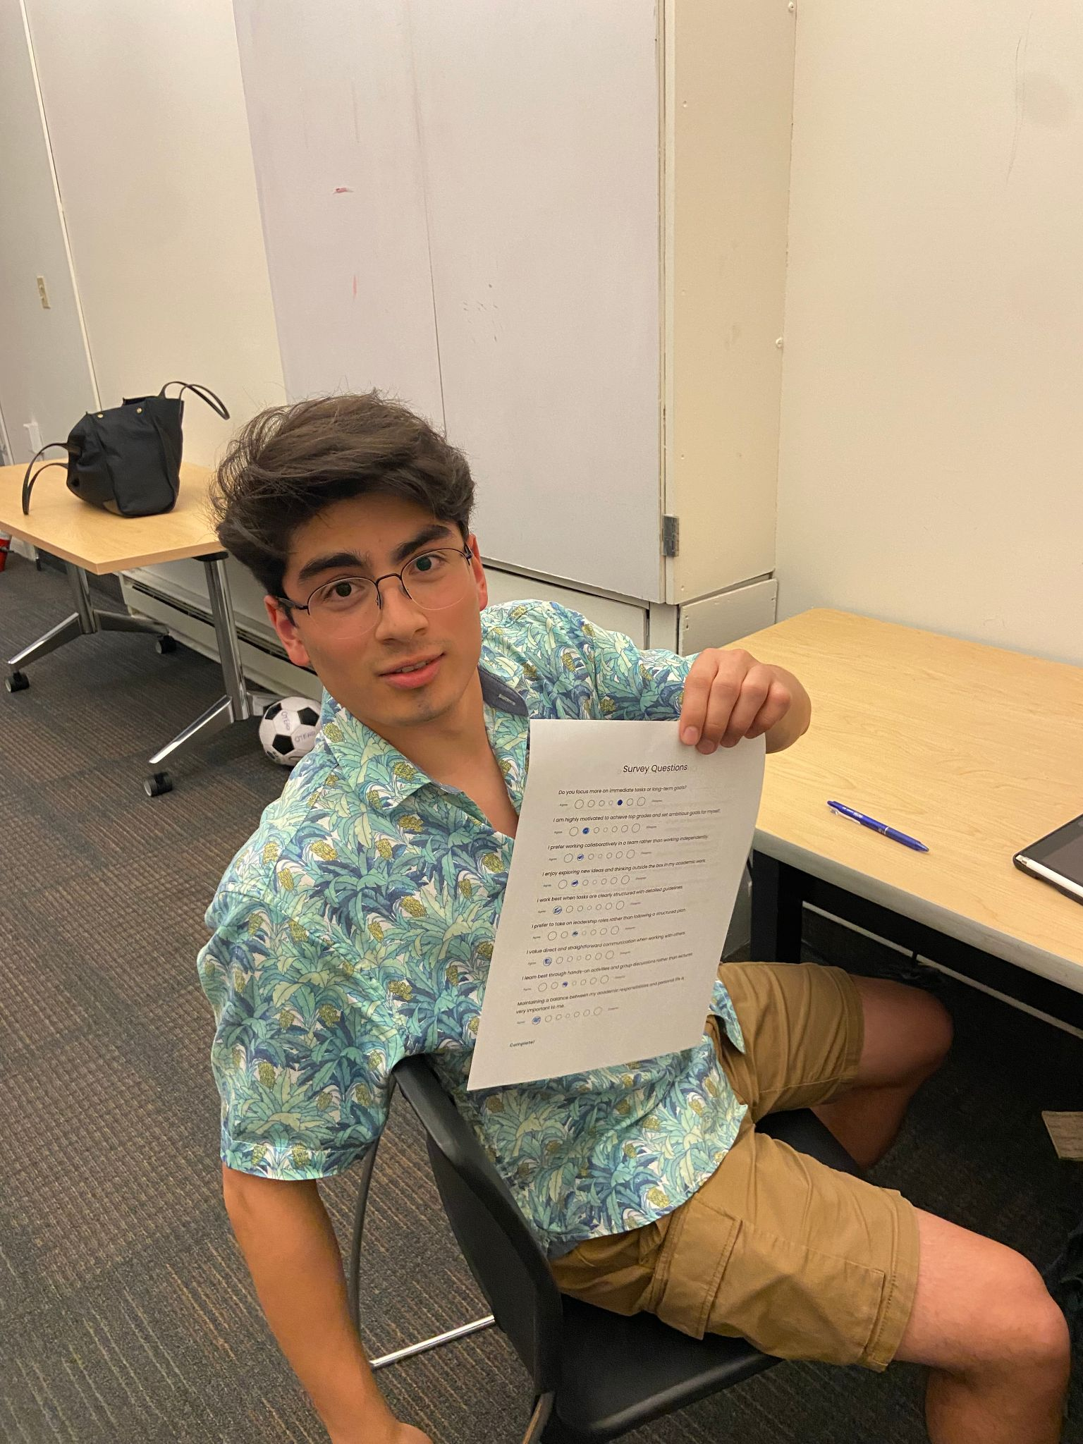

Figure 9 - Our first experience prototype and test participants

**What worked:** Participants said it was both easy to use and informative on a personal level. They appeared to enjoy answering the survey questions and expressed interest in finding study partners in multiple classes.

**What didn’t:** Participants noted that the lack of definitive scheduling questions may lead to scheduling conflicts in the future

**Assumption: Assumption validated**. Students are open to, and more than happy to, create profiles for themselves and match with those whose studying habits or personalities matched their own.

**Experience Prototype #2**

***Assumption*** *-* People know and can share their study availability in advance

**Description:** We created a schedule where users can fill in the times that they *would* like to study

**Props:** We created a physical “schedule worksheet” containing questions relevant to scheduling availability. Discussions took place after completion.

**Participants & Relevance:** The participants were all Stanford students, mostly undergraduates under the engineering school. They were recruited through warm contacts.

**Method:** A person was asked to thoughtfully fill out the scheduling worksheet, and asked if they would be willing to form a study group with other participants, judging by their previously filled schedules.

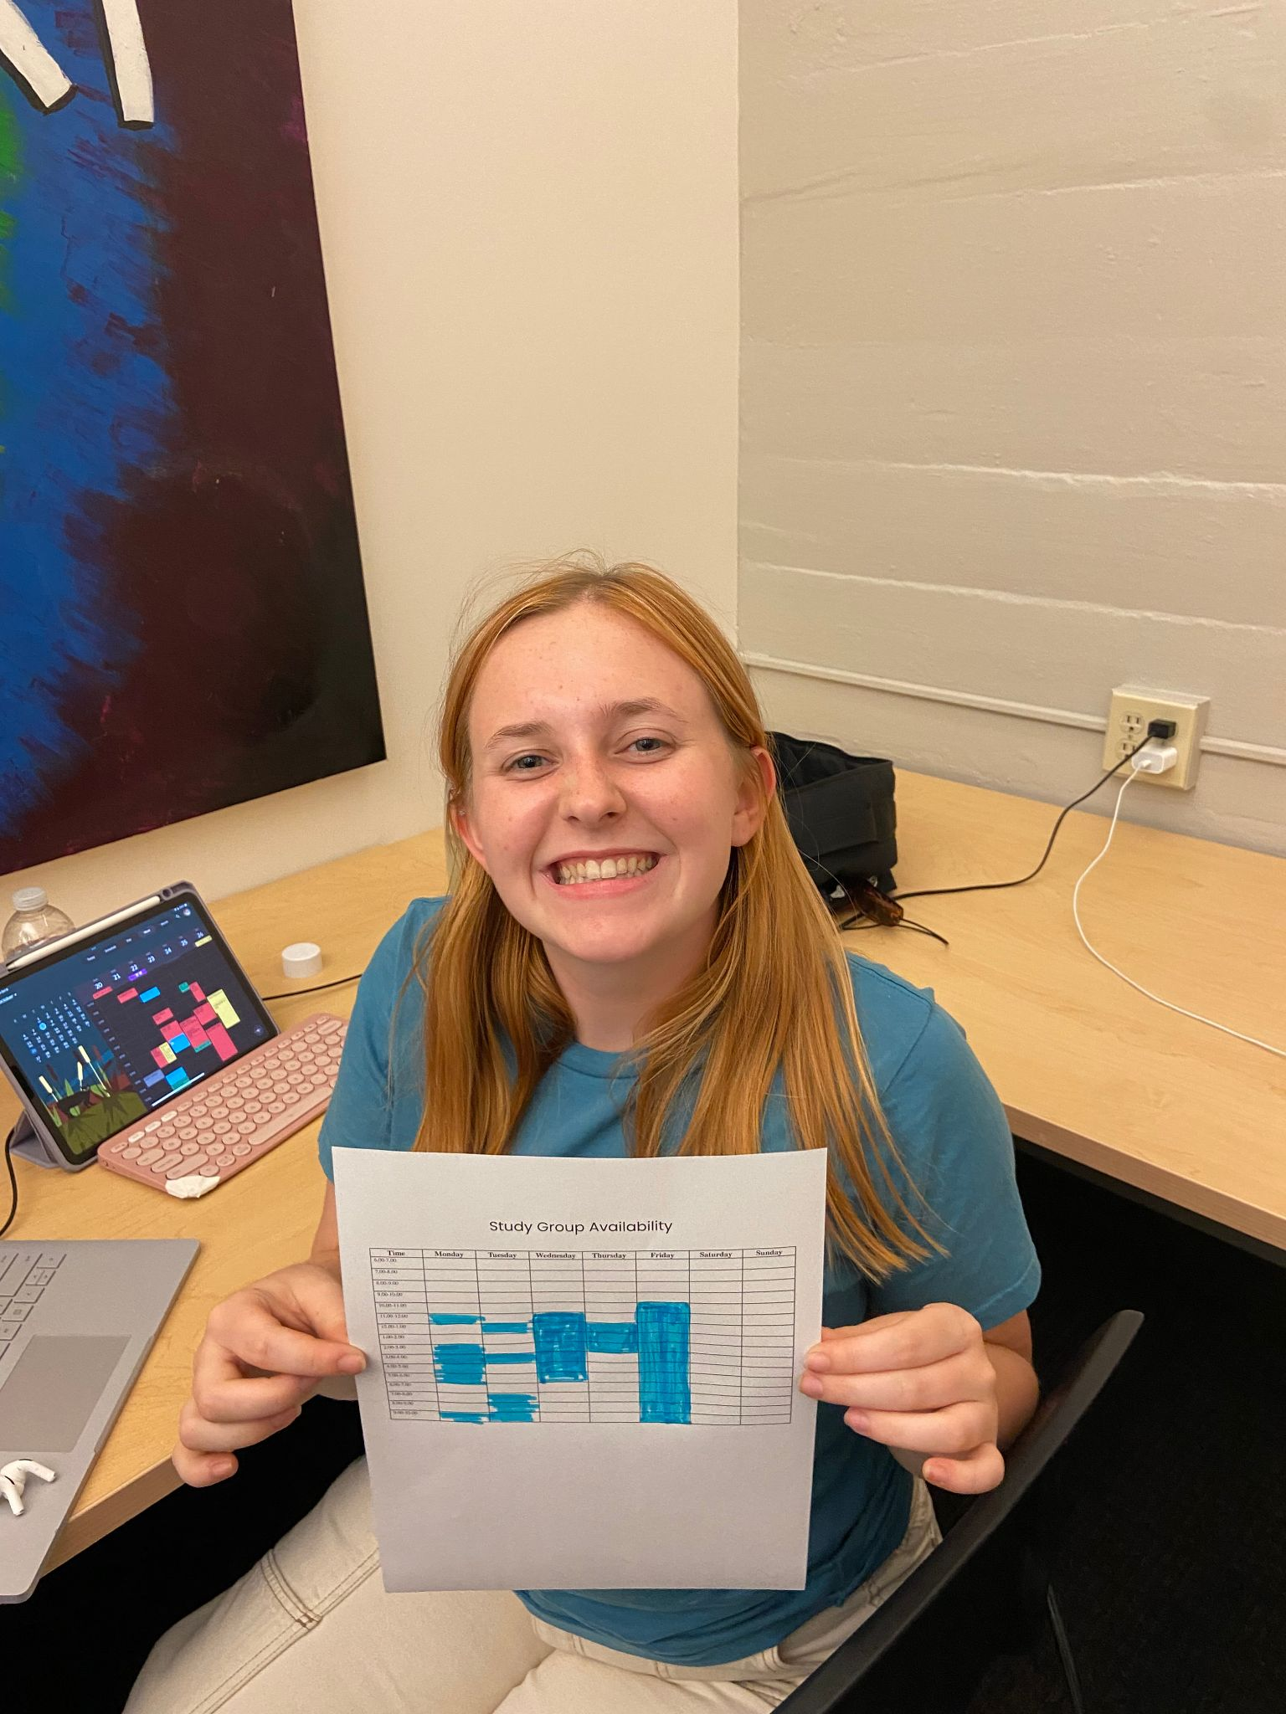

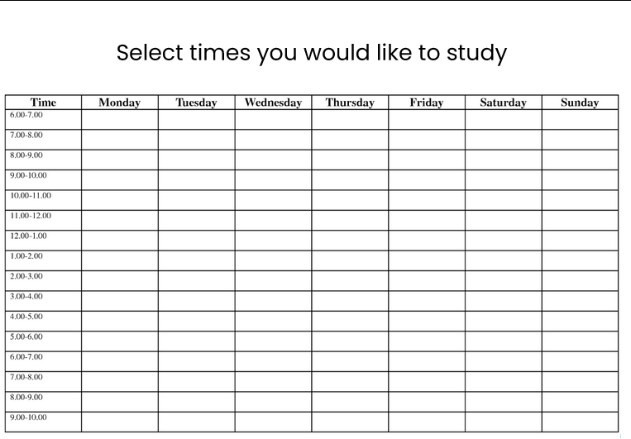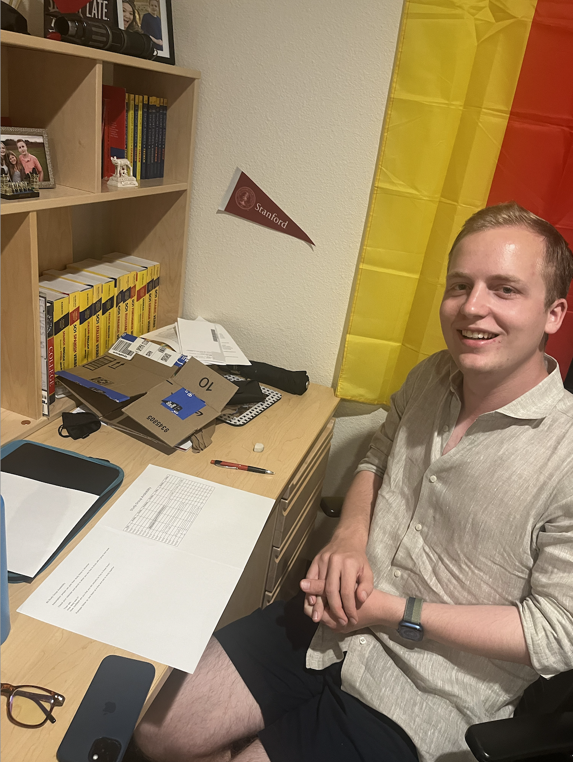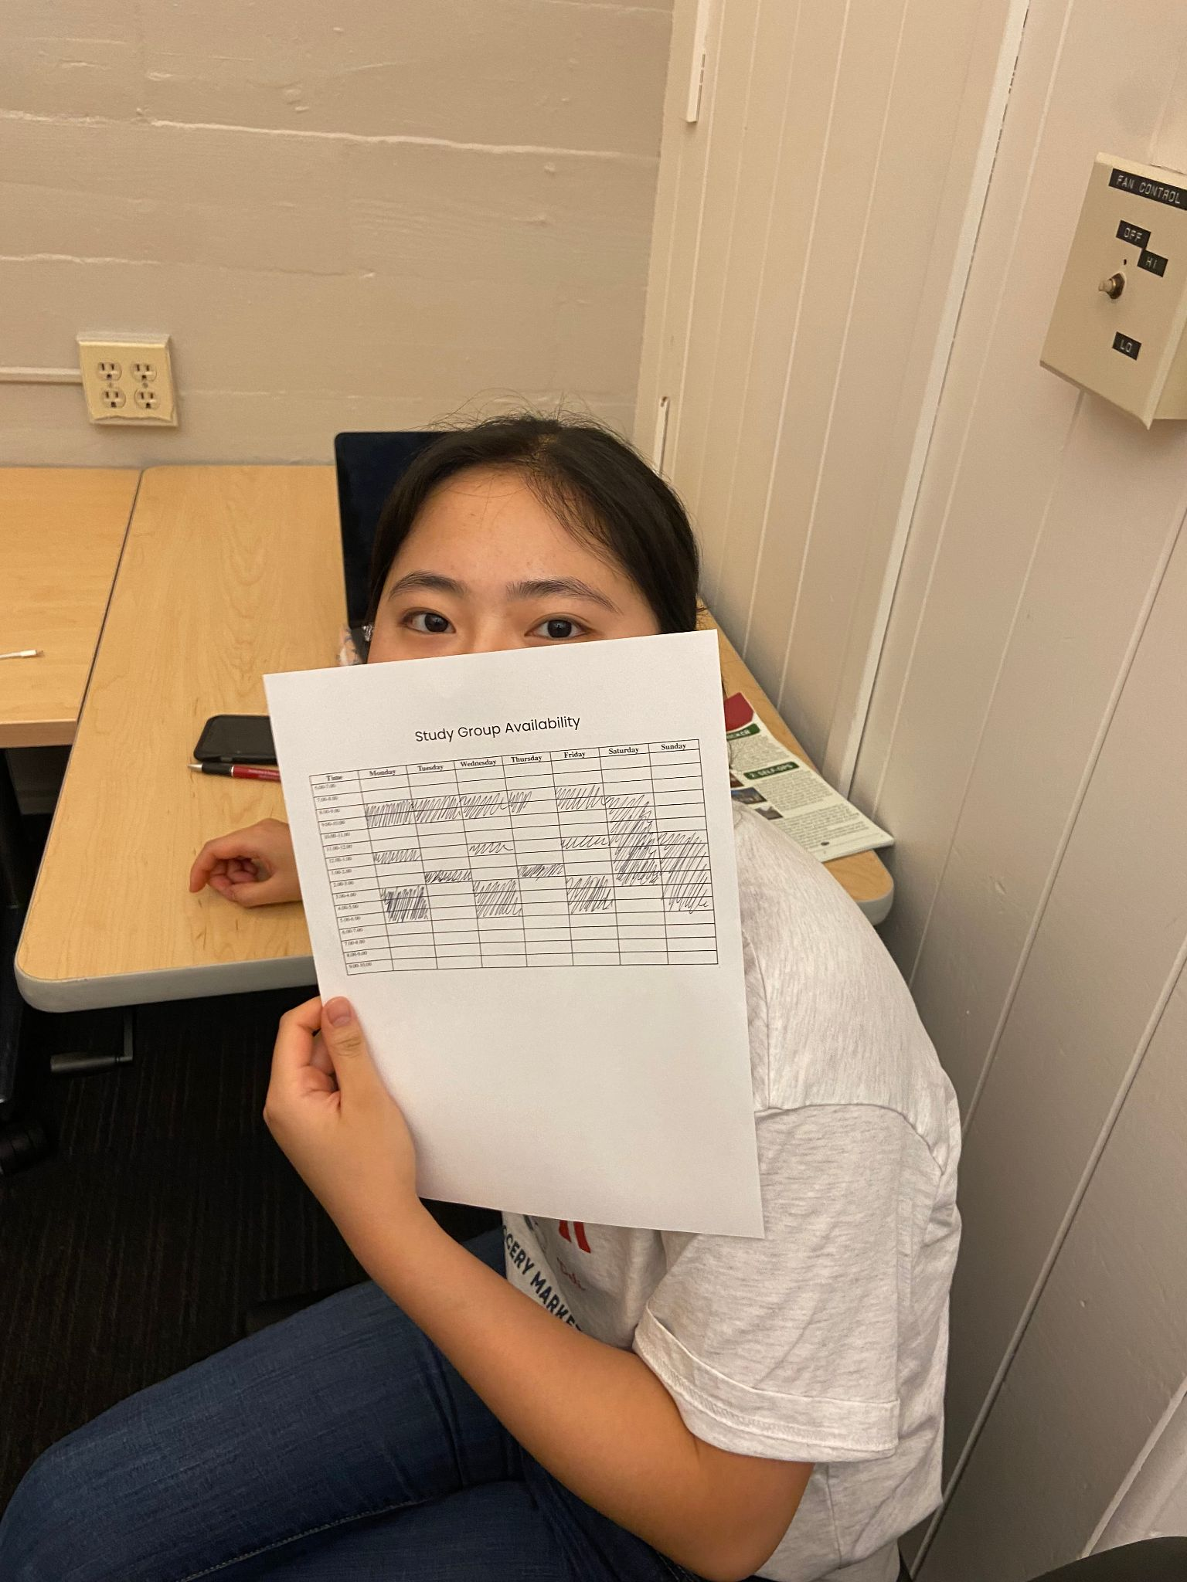

Figure 10 - Our second experience prototype and test participants

**What worked:** Participants said it was easy to fill and compare, yet insufficient in giving enough information about the potential study partner to be convincing

**What didn’t:** Participants noted that schedules vary a lot throughout the quarter and their availabilities could change unpredictably. In addition, they expressed unpleasant feelings about planning logistics

**Assumption: Assumption somewhat validated.** Stanford students can plan their schedules beforehand, but are hesitant to make long-term commitments, and find the process unappealing.

**Experience Prototype #3**

***Assumption*** *-* People want to ask study app or resource questions to a LLM

**Description:** We created an “LLM” that **takes in** user questions related to school/career and returns outlined steps reaching said goals or relevant resources

**Props:** Our prototype was a text message thread that acts as an “LLM” with people ready to respond after user sends questions. Discussion took place after the exercise.

**Participants & Relevance:** The participant was a Stanford student interested in EE, with industry background. He was recruited as a friend, and was particularly relevant because he is back after a leave and is trying to get study help and find resources.

**Method:** The participant was asked to text the LLM whenever he had questions on classes, studying, or resources over a 3-hour period. He was on standby to reply as an LLM, using knowledge of Stanford & EE.

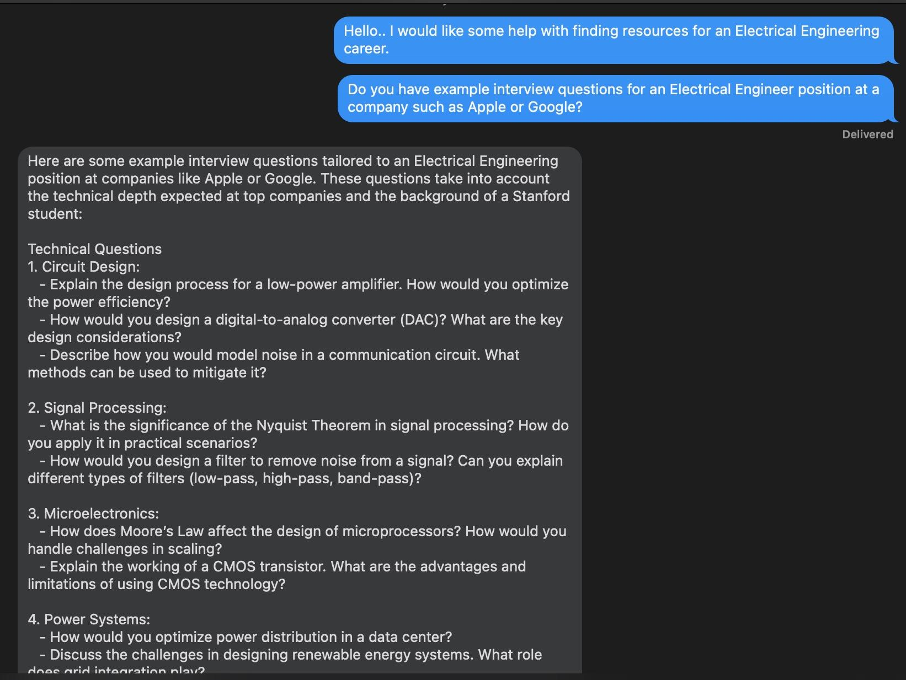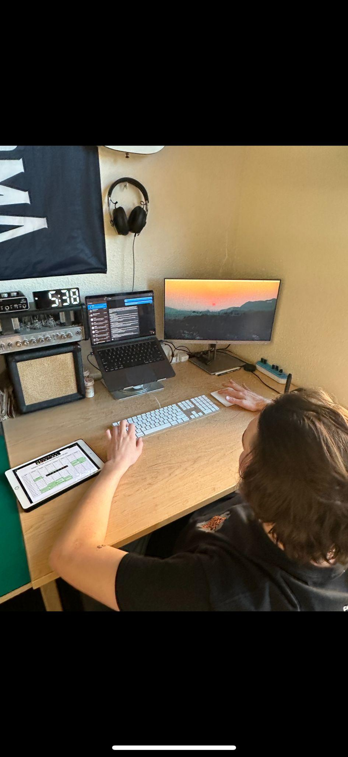

Figure 11 - Our third experience prototype and test participant

**What worked:** Our participant appreciated how easy it was to use and the range of functionality (how to access X resource? How to best study for [class]? What classes/ actions can I take to break into Y career)?

**What didn’t:** 1) Scraping for very niche or protected information is difficult, could lead to generic or unhelpful answers. 2) Training on school-specific information has many barriers

**Assumption: Validated,** users find LLMs useful for asking a variety of questions and tend to do so without hesitation (less confrontational than asking others)

**Design Evolution**

**Final Solution**

We collect information from students in classes and use AI enhanced tools paired with research on effective collaboration practices to automatically plan recurring study sessions and manage group projects. To further differentiate our product from existing solutions, we introduced a feature that goes beyond simply matching students based on their study profiles. We added a study plan creation tool, leveraging AI to organize user-uploaded class materials into actionable tasks. This added functionality is designed to better support students throughout their academic journey.

**Tasks**

Our solution provides a seamless and user-friendly experience to aid facilitate collaborative studying. LockedIn’s platform also provides easy access to a robust AI system that organizes document, such as class syllabi, into concise, manageable tasks. The three main app flows are categorized into three tasks: simple, moderate, and complex. New users are introduced to our app through an informative onboarding process.

Task #0 – *Onboarding*

The onboarding process consists of two main components: an introductory overview of tasks and a login page for user authentication. The purpose of the onboarding screens is to provide a high-level overview of LockedIn’s core functionalities. For our login system, we integrate Google’s sign-in architecture for efficiency and to follow industry standards.

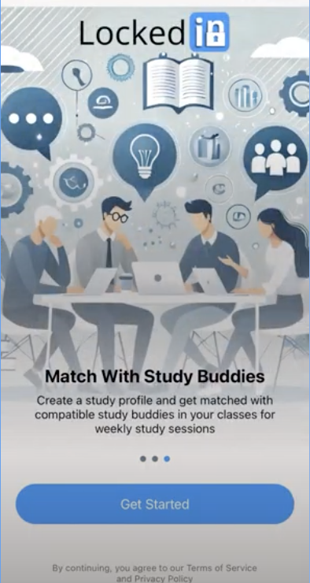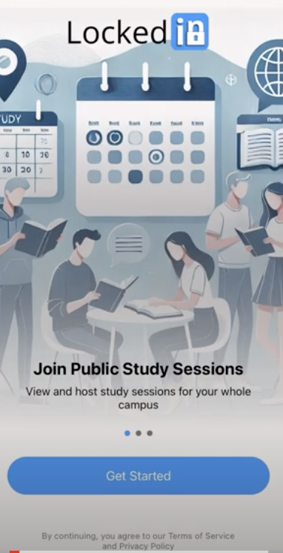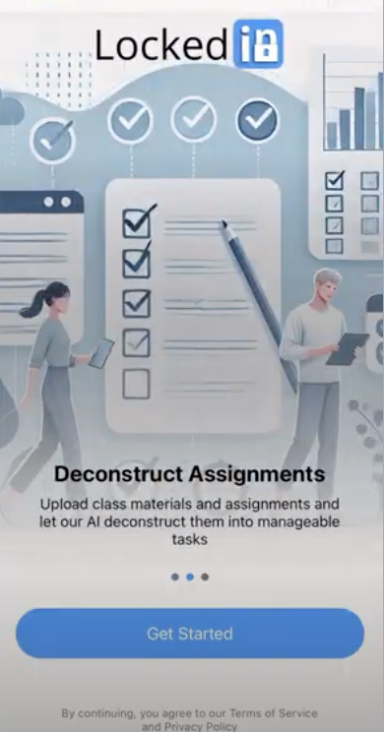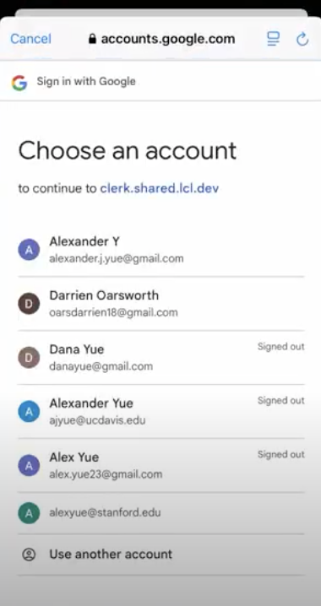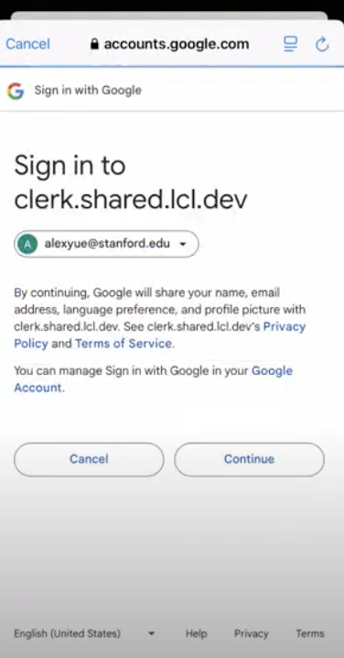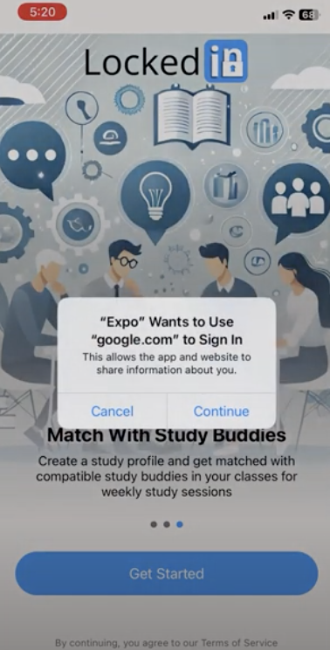

Figure 12 - Onboarding screens (left 3) and login screens (right 3)

*Task #1 - Simple - Discover and create open study sessions for a class*

A key feature of our app is enabling students to easily join pre-existing study sessions, providing them with more opportunities to collaborate with their peers. As part of this task, users can create their own public or private study sessions, which will be displayed on a publicly accessible home feed.

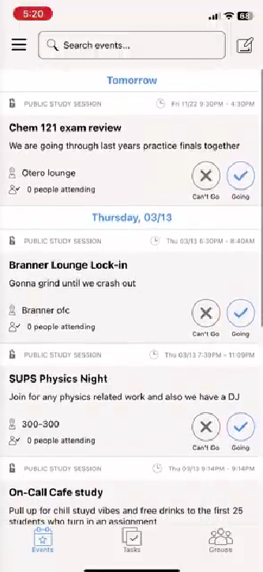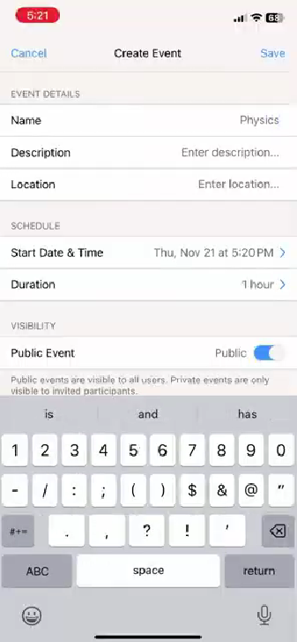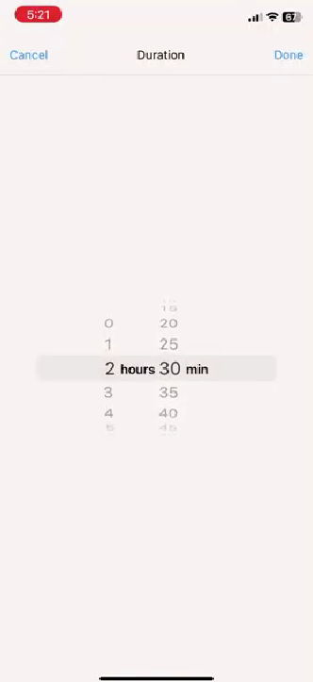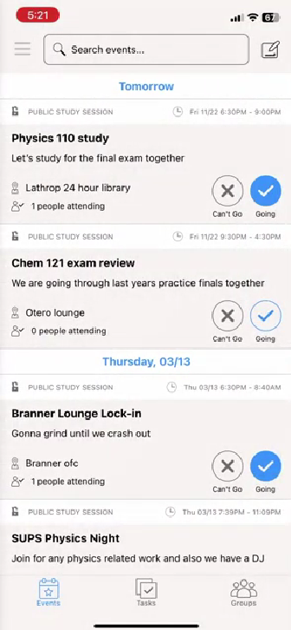

Figure 13 - HiFi task flow for discovering and creating events

*Task#2 - Moderate - Upload class syllabi and assignments to get AI powered study plans and group project task delegation*

This newly defined feature allows users to upload relevant class material, such as syllabi or assignments, to our AI system. The AI system processes documents and extracts actionable tasks, which users can edit to their personal preferences. This task flow helps users save time and easily manage multiple resources across their classes.

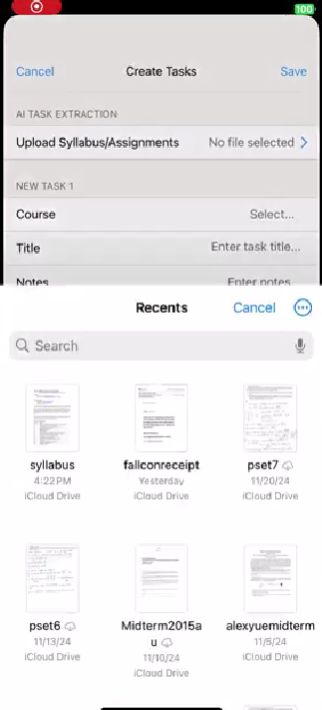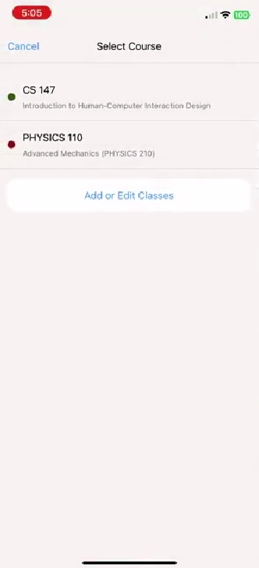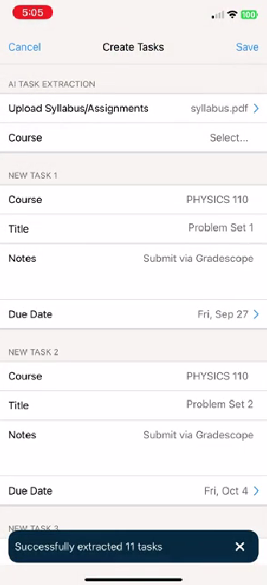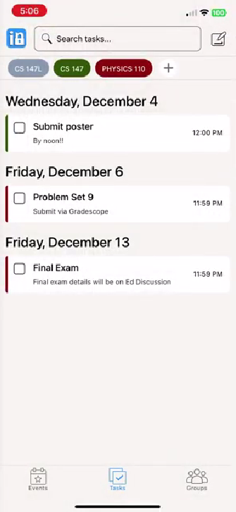

Figure 14 - HiFi task flow for creating AI generated tasks

*Task #3 - Complex - Create a study profile and get matched with recurring partners/study groups*

Connecting study partners together to foster collaboration is one of LockedIn’s core goals. In this task flow, we provide a profile survey that includes questions pertaining to a student’s study habits, preferences, and schedule. Our AI matching system pairs users with others who have similar profiles, promoting more effective and consistent study group connections.

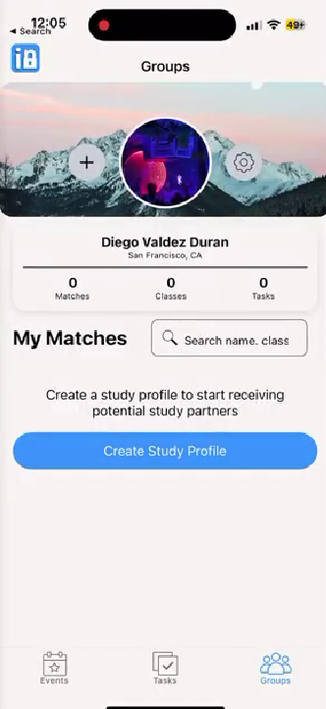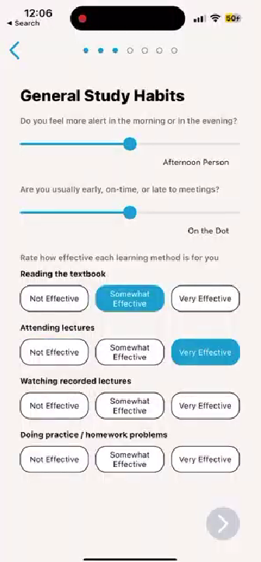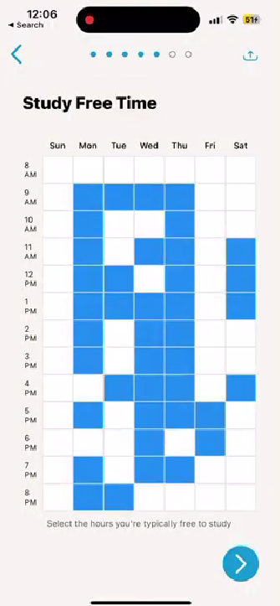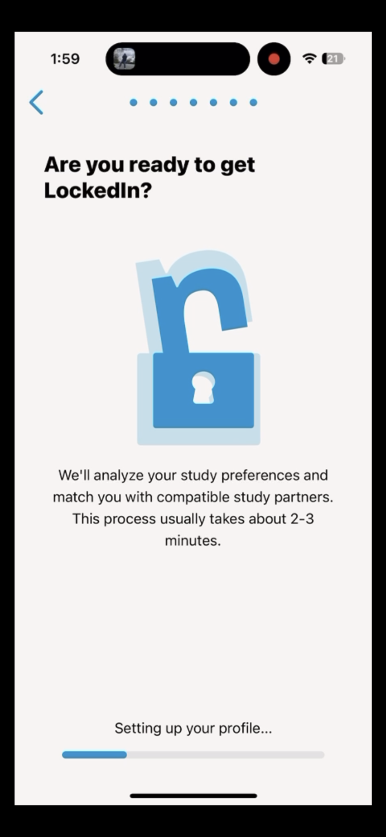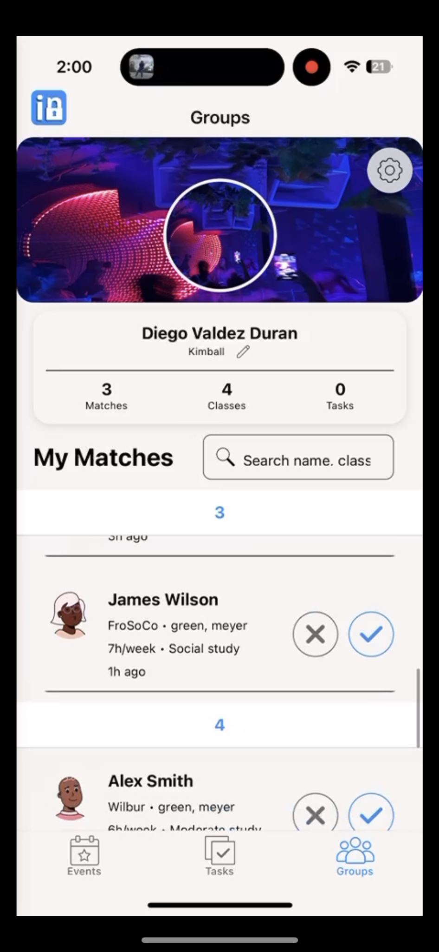

Figure 15 - HiFi task flow creating study profile and finding matches

**Initial Sketches**

During the early stages of our design process, we created various concept sketches for our app. Together, we crafted different realizations for our app, including wearable, VR, and mobile app versions. Ultimately, we decided to pursue the mobile app for the following reasons:

• Familiarity, intuitiveness, and a balance of icons, text, and buttons

• Accessibility, no need for special hardware or devices

• Simplicity, easy to update and iterate based on feedback

• Easily navigable, has a lower learning curve

**Lo-Fi Prototype**

After deciding to move forward with a mobile application, we began sketching individual screens for our prototype. Our goal was to create the interface of each screen needed to complete the task flows. Below are visualizations of the sketches for our profile survey and matching features.

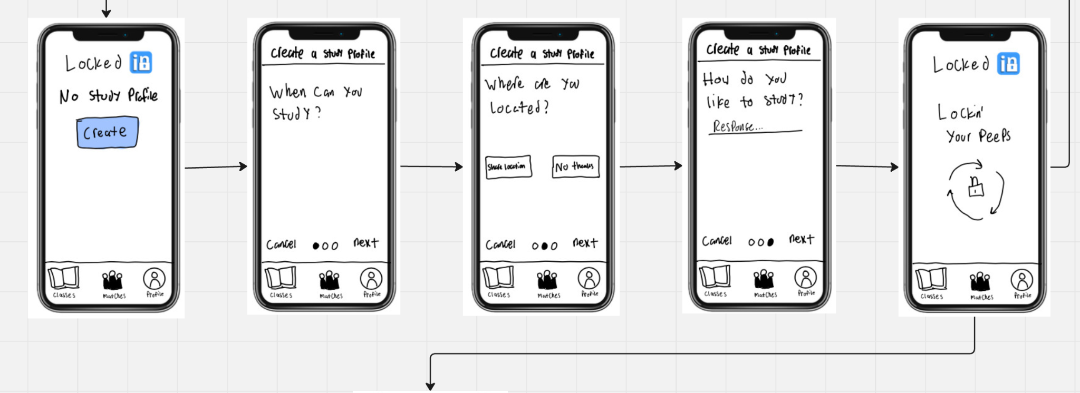

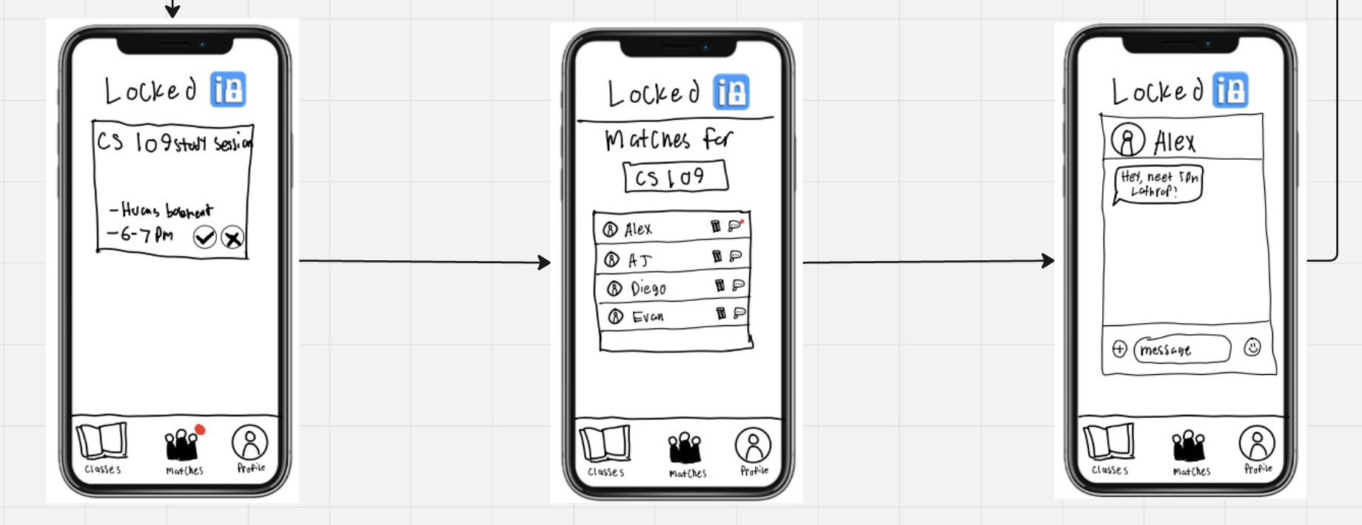

Figure 16 - Sketch of our profile survey + matching users task flow

Our Lo-Fi prototype resulted in a paper prototype, where we printed each screen and cut out the individual phone-sized screens to prepare for user testing.

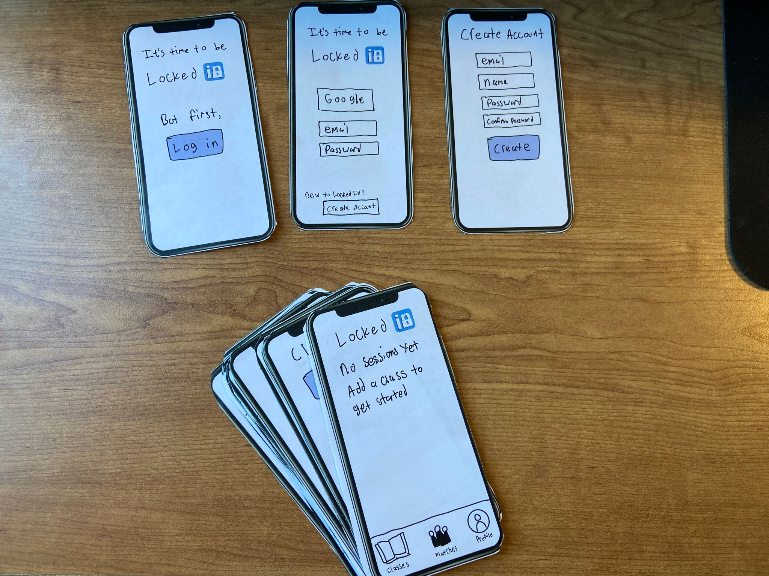

Figure 17 - Paper cutout screens of our Lo-Fi prototype

**User Testing**

After preparing our Lo-Fi prototype, our team conducted user testing with four participants from our target demographic (undergraduate students). Our testing process is as follows:

* Sourced participant by asking friends and using a dorm Slack channel to find students visiting from other colleges
* Printed and cut out hand-drawn phone screens
* Participants were asked to speak aloud while performing tasks and use hand gestures to describe their thought processes. The team member would then provide the appropriate next screen
* We tracked all actions made by the participant, noting the critical incidents
* After the testing sessions, we reviewed our notes to evaluate the critical incidents and analyze user behavior
* Compensation varied by user and included buying boba

**Conclusions**

Following our user tests, we analyzed the critical incidents and derived the following key insights:

* Task flows were largely successful, but user flow between tasks was lacking
* A high level overview of how the solution works should be presented at the beginning
* Completing tasks and getting results needs more responsiveness and interactivity
* Study profiles should have different levels of complexity for different kinds of users

In response to our new insights from user testing, we took the improvement areas into consideration in the development of our Med-Fi prototype.

Planned Changes

* **Improve Responsiveness and Flow**: We will focus on creating a smoother user experience in our Med-Fi prototype
* **Add Onboarding Process**: We will provide an overview of our app’s core features across a few informational screens

Features to Further Develop

* **Study Profile Complexity**: We will conduct preliminary surveys at three levels to understand what various users need
* **Banner Notifications**: We plan to explore the suggestion of using banner notifications to alert users when they receive a study partner match or a study group invitation

**Med-Fi Prototype**

Building our Med-Fi prototype, we implemented the changes based on user feedback. To address the need for an overview of our app’s available tasks, we added an onboarding process. We also refined our survey questions to capture the necessary information needed to make a complete profile. Finally, we decided to include banner notifications to keep users informed about task completion and next steps.

We used Figma to construct our Med-Fi prototype, which facilitated collaboration through live updates and provided valuable resources for building the prototype efficiently.

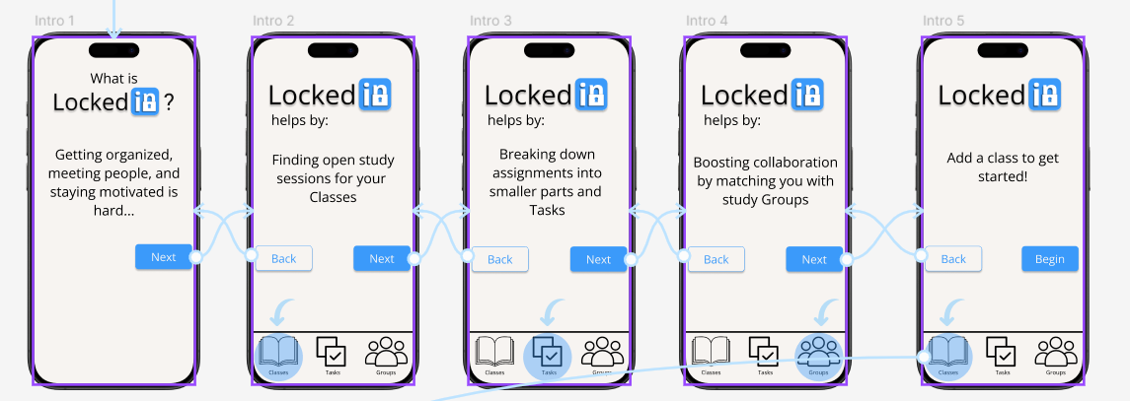

Figure 18 - Figma mockup of our new onboarding sequence

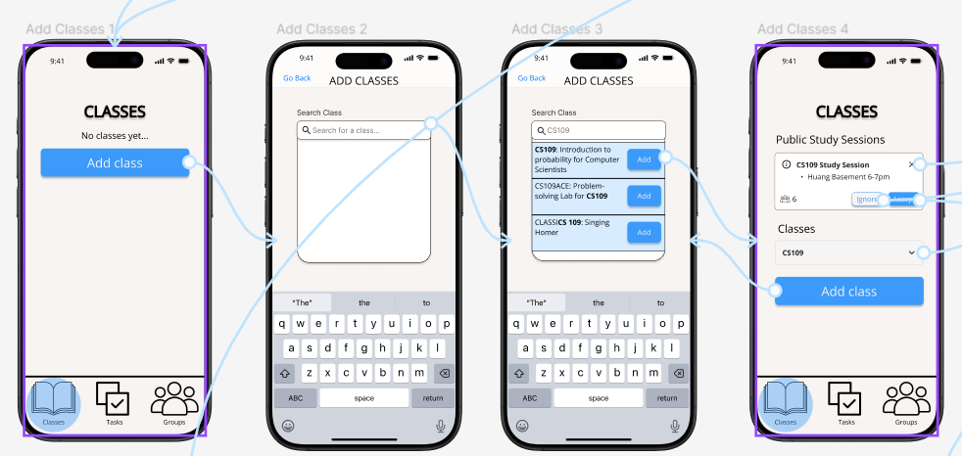

Figure 19 - Figma mockup of adding classes and viewing study sessions

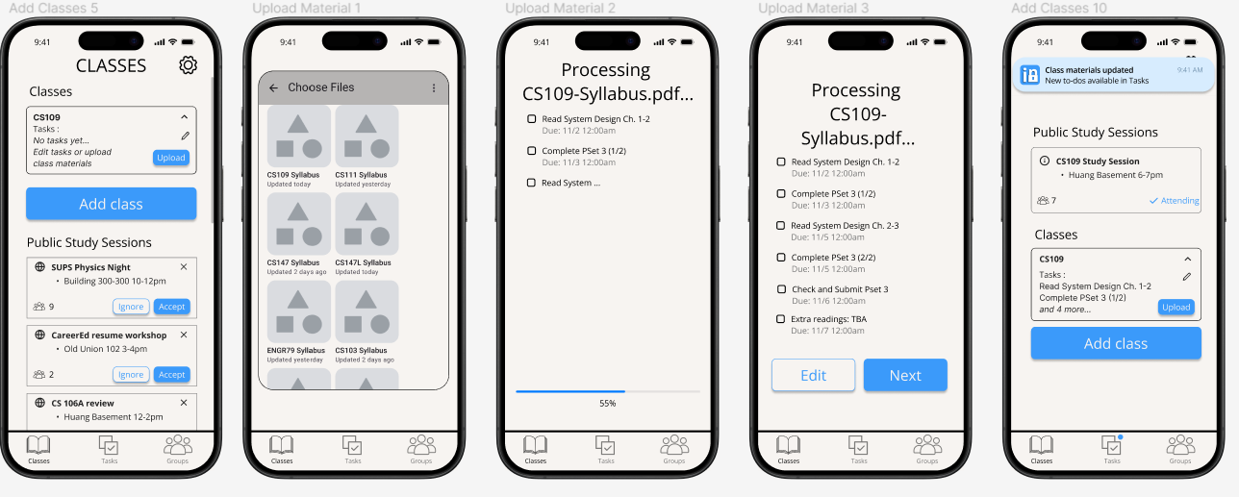

Figure 20 - Figma mockup of our uploading class materials task flow

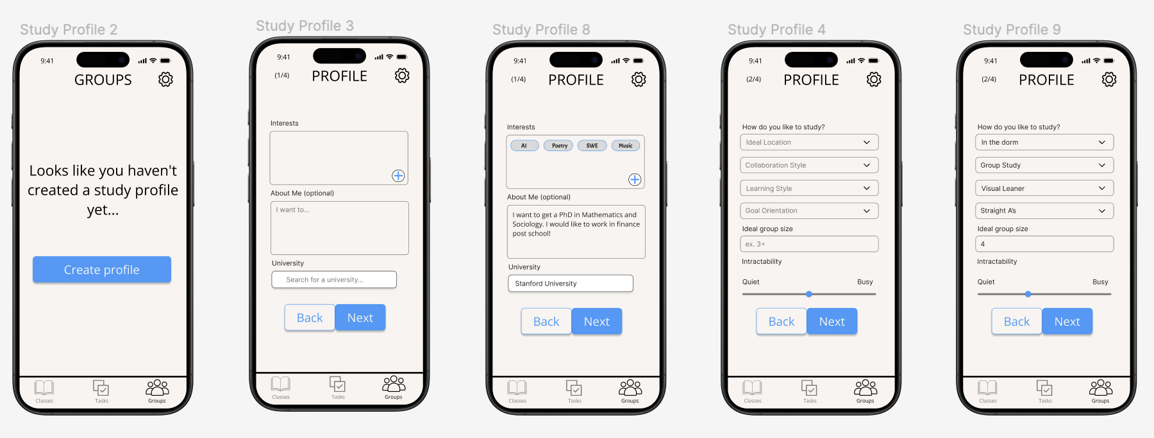

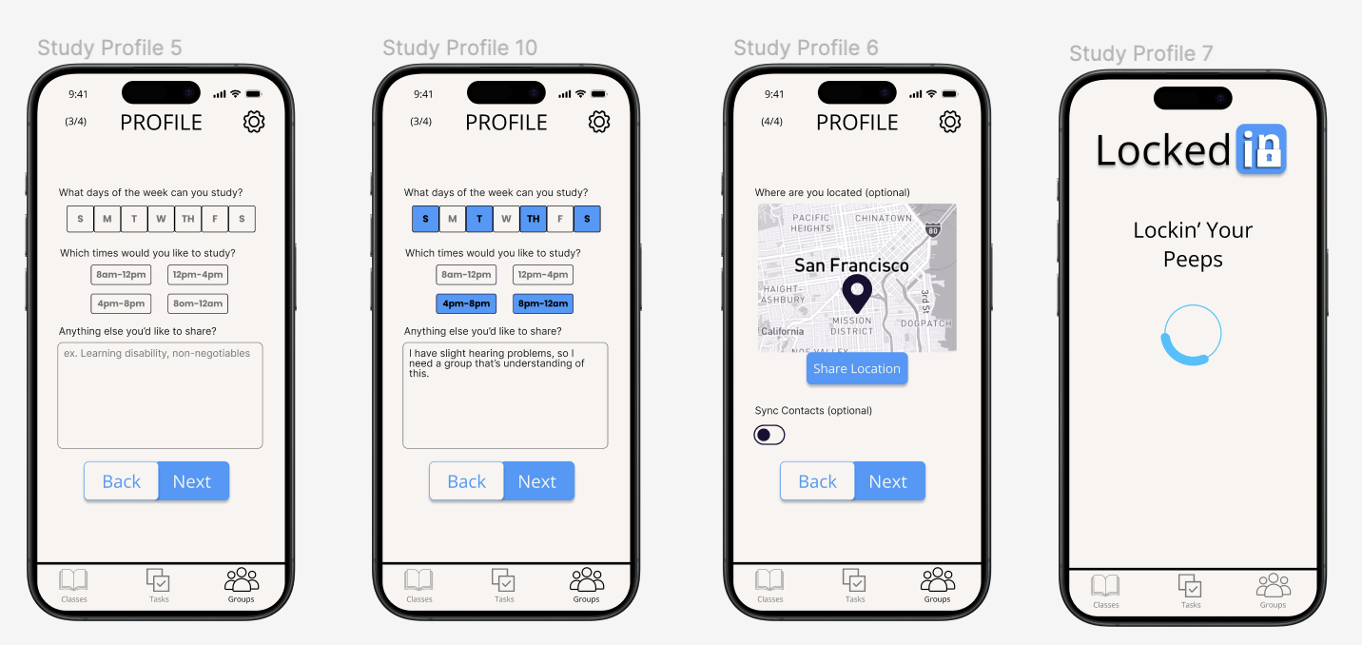

Figure 21 - Figma mockup of profile survey

**Med-Fi Evaluation**

Our Med-Fi prototype was assigned to other members in our studio for heuristic evaluation. In total, we received 46 violations, with 2 severity 4 violations and 14 severity 3 violations. Among these violations, H4: Consistency & Standards was the most common heuristic for our severity 3 violations. Given this feedback, our team extracted the following themes for analysis:

Qualitative Summary

* **Inconsistencies in Design:** interfacing styling (buttons, fonts, padding)
* **Navigation:** inoperable tab bar
* **Appearance:** color scheme
* **Accessibility:** could add voice-input, adjustable text
* **Terminology:** ambiguous terms
* **Advanced Interactions:** could add swiping capability

We focused on inconsistencies in design, navigation, and terminology for our UI revisions. Since vibrant colors are challenging to overlay, we decided to stick to Professor Landay’s recommendation of using a single accent color. We recognize that the additional features for accessibility and advanced interactions are important for a final product, however we will not move forward with these new additions because they fall outside the scope of our Hi-Fi prototype. During the construction of our Hi-Fi prototype, we directly addressed each of the severity 3-4 violations.

*Severity 4 Violations*

**H3: User Control & Freedom | Severity: 4**

* Problem Addressed: Tab bar is not functional across all screens
* Revision: We made sure that the navbar is always active throughout the app

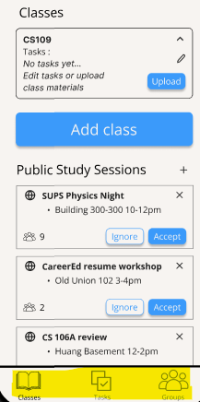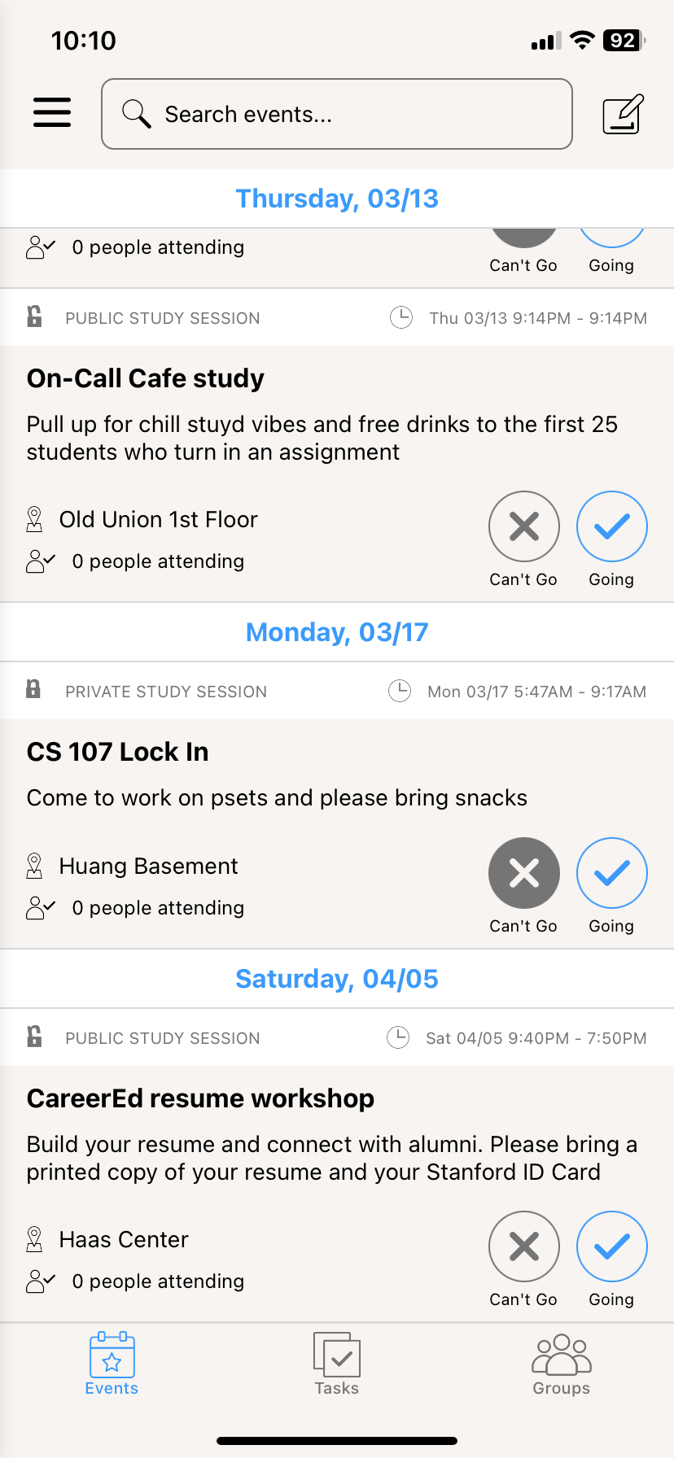

**→**

Figure 22 - UI Revision from Med-Fi to Hi-Fi for tab bar

**H8: Aesthetic & Minimalist Design | Severity: 4**

* Problem Addressed: Unreadability after repeated clicking of “Edit” icon
* Revision: Although we could not reproduce this visual glitch in Figma, we ensured that the Hi-Fi prototype buttons function as expected

*Severity 3 Violations*

**H4: Consistency & Standards | Severity: 3**

* Problem Addressed: Attendance withdrawal icon is not intuitive
* Revision: Replaced variable buttons with two toggle radio buttons

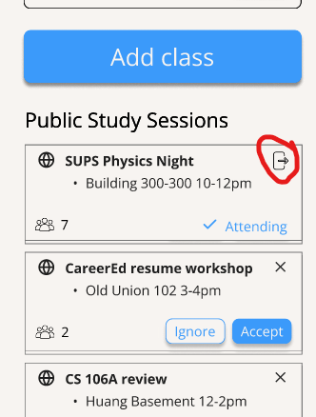

**→**

Figure 23 - UI Revision from Med-Fi to Hi-Fi for attendance withdrawal

**H4: Consistency & Standards | Severity: 3**

* Problem Addressed: Potential confusion between “study sessions” and “groups”
* Revision: Moved all study sessions into a tab labeled “Events”

**H9: Help Users with Errors | Severity: 3**

* Problem Addressed: No indication when a public study session is full
* Revision: We do not intend for public study sessions to have a max capacity. This will be made clearer in the onboarding process

**H3: User Control & Freedom | Severity: 3**

* Problem Addressed: No button to cancel uploading process
* Revision: Added a cancel button during upload process

**H3: User Control & Freedom | Severity: 3**

* Problem Addressed: No method to recover a deleted task
* Revision: Used Toast (temporary popup) with undo button

**H5: Error Prevention | Severity: 3**

* Problem Addressed: No confirmation to delete a task
* Revision: With the new toast method of easy recover, we determined that adding a confirmation step would be unnecessary and slow users down

**H1: Visibility of System Status | Severity: 3**

* Problem Addressed: The label “Processing [resource]” is unclear
* Revision: Relabeled the label to “Extracting Tasks from [resource]”

**H1: Visibility of System Status | Severity: 3**

* Problem Addressed: The result of uploading materials is vague
* Revision: We believe that the notification “Class materials updated: New to-do’s available in Tasks” is an adequate way to inform users that uploaded material creates new tasks

**H4: Consistency and Standards | Severity: 3**

* Problem Addressed: Toggles on share location screen are unconventional
* Revision: Fixed toggle coloring, gray for “off”, blue for “on”

**H8: Aesthetic & Minimalist Design | Severity: 3**

* Problem Addressed: Uniform, minimal color scheme used throughout
* Revision: We decided not to add additional accent colors, but we did add more white and gray shades to use as separators within app feeds

**H6: Recognition not Recall | Severity: 3**

* Problem Addressed: Study sessions are not grouped by class
* Revision: The class is now automatically rendered into the title of study sessions

**H2: Match b/w System & World | Severity: 3**

* Problem Addressed: “Intractability is ambiguous in one of the profile survey questions
* Revision: We changed this term to “Noise Level” for clarification

**H4: Consistency & Standards | Severity: 3**

* Problem Addressed: No indication of required fields
* Revision: Added asterisks besides required fields

**H4: Consistency & Standards | Severity: 3**

* Problem Addressed: Margin and padding on the onboarding pages are inconsistent
* Revision: Upgraded our onboarding pages into a single page with an information carousel with consistent formatting

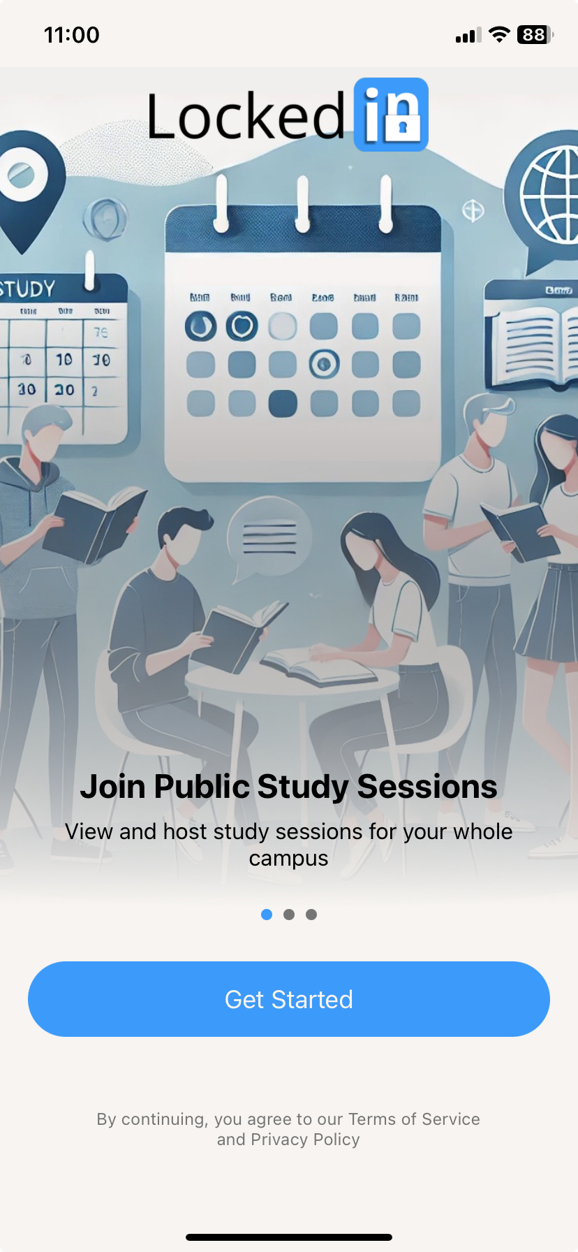

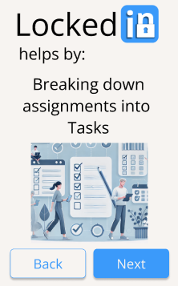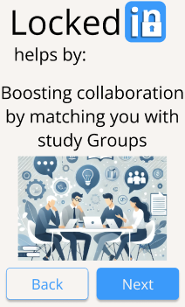

**→**

Figure 24 - UI Revision from Med-Fi to Hi-Fi for onboarding screens

**Values in Design**

**Usability Goals**

Our prototyping revisions are steps towards our usability goals: efficiency and error prevention + recovery.

1. **Efficiency**- our app flow aims to minimize the number of steps required to complete key tasks
   * Navbar is now always active across all screens, minimizing navigation steps for tasks
   * Redefined the “Study Sessions” tab as “Events” for clearer organization and to reduce confusion
   * Added a “Cancel” button for uploads and optimized task recovery with an undo button
   * Reformatted the intro page into a consistent carousel format, providing quicker access to app info
2. **Error Prevention and Recovery**- our app flow aims to mitigate misclicks and allow users to recover easily when they occur
   * Introduced * and consistent markers for required fields to prevent user submission errors
   * Replaced ambiguous labels like “Intractability” with “Noise Level” to avoid misinterpretations
   * Added clear feedback like “Class materials updated, new to-dos available in Tasks” for tasks
   * Toast notifications with undo buttons enable immediate recovery from accidental deletions
   * Toggle radio buttons simplify navigation between attendance states, reducing errors

**Our Values**

*Inclusivity*

Inclusivity is at the core of our app’s design. We support a wide range of user needs by offering features that allow for more personalized and context-driven experiences. For example, we grouped study sessions by class, enabling better matching of peers based on their course context. This allows students to find study partners or groups who are taking the same courses. Additionally, we improved the onboarding process to clarify the app’s features, ensuring that users from all backgrounds can easily understand and navigate the platform.

*Intuitiveness*

Our app prioritizes intuitive design to ensure a smooth and seamless user experience. We simplified the interaction design by adjusting the color scheme to create more consistency and improve toggle visibility. Our goal is making the interface easy to use. The revisions were made so users can quickly understand and interact with the app without confusion. Additionally, we relabeled key processes, such as “Extracting Tasks,” to make them clearer for users. This helped eliminate any ambiguity, ensuring the app feels natural and straightforward.

*Reliability*

Reliability is fundamental to user satisfaction, and we focused on improving consistency across the app. We made necessary fixes, such as addressing the margins and padding on intro pages to create a more visually cohesive experience. Additionally, we resolved potential usability bugs in the edit buttons, ensuring they function as expected and provide users with the reliability they need when interacting with the app. These enhancements guarantee that users can count on our app to perform as intended, with consistent behavior across different prototypes.

*Trustworthiness*

Trust is essential to maintain positive relationships between our app and its users. We focused on transparent communication, particularly by clarifying the onboarding process and providing accurate descriptions of the app’s features. This ensures users fully understand what the app can offer and how it works. Furthermore, we prioritized user-centric decisions, such as eliminating unnecessary deletion confirmations, to enhance the app’s efficiency and make the overall experience smoother. These improvements reinforce our commitment to building trust by offering users an intuitive, transparent, and efficient platform. We highly value privacy, and will protect our users’ privacy to the best of our ability.

**Final Prototype Implementation**

Our final Hi-Fi prototype was a functioning mobile application that runs on both iOS and Android devices. The prototype features a working frontend and a limited backend.

**Tools Used**

We used an extensive tech stack to construct our prototype, which enabled us to create an app experience closely resembling a real product.

1. **Expo Go**

Pros: cross-platform compatibility, supports hot reloading

Cons: limited customization

1. **React Native**

Pros: deploys on both iOS and Android, massive ecosystem of libraries

Cons: performance overhead, fragmentation

1. **Convex**

Pros: serverless backend, real-time data sync

Cons: limited flexibility, vendor lock-in

1. **OAuth**

Pros: widely used, scalable

Cons: complex setup, token management

1. **Clerk**

Pros: user-authentication, multi-factor authentication

Cons: limited customization, pricing

1. **OpenAI API**

Pros: advanced AI models, ease of use

Cons: cost, data privacy concerns

1. **Github**

Pros: version control, collaboration features

Cons: learning curve

1. **Claude 3.5 + Cursor Pro**

Pros: AI-powered assistance, increased efficiency

Cons: accuracy

In addition, we included miscellaneous packages to assist with our app development

* Task Management - Miro
* Android App testing - Android studio
* Coding Language - Typescript
* UI Package - Tamagui with custom config
* Animation - React Animated
* Iconography - powerpoint + inkscape

**Wizard of Oz Techniques**

In order to create a finished product, we employed Wizard of Oz techniques to simulate features beyond the scope of our app. The techniques we used are detailed below:

*AI Matching*

Employing AI matching between similar profiles as a wizard of oz technique allowed us to simulate the AI-driven matching process within our prototype without fully implementing the backend functionality. Users completed the survey questions about their study habits, preferences, and schedules, as they would in the final version of our app. However, instead of having the AI system automatically matching users based on their responses, we would display preset matches following the survey completion. This approach enabled us to test the user interface without the complexity of building an entire AI system and having a large active user base.

**Hard-coded Features**

*Preset Study Sessions*

The study sessions listed in the home feed are not generated from real users. The developers hard coded the example study sessions for testing and prototype construction purposes. Users can post new study sessions that will be added to the home feed, but these updates do not persist on other users’ screens.



Figure 25 - Example of hard coded study sessions on home feed

**Reflection and Next Steps**

**Main Learnings**

Through the development and refinement of our LockedIn prototype, we gained valuable insights that informed our design and user experience choices. One key takeaway from our process was the importance of balancing simplicity with functionality. We aimed to include the minimum number of screens needed to complete the task flow for efficiency. Our needfinding process revealed that students faced significant barriers when trying to connect with their classmates, such as social anxiety and scheduling conflicts. By leveraging AI to create study plans and match students, we were able to address these pain points. During the formation of our task flows, we learned that smooth navigation between tasks and app responsiveness to task completion were critical to improving user engagement. Additionally, multiple rounds of user testing revealed the challenges of managing complexity, especially regarding profile and study plan creation. These findings have influenced our decisions between each stage of the prototype development.

Key learnings are summarized below

* **User-Centric Design:** we conducted needfinding interviews to inform our design solutions
* **Wizard of Oz Techniques:** using simulated AI features, we did not overcomplicate the early stages of development
* **Simplicity and Functionality:** we struck a balance between offering personalized features and keeping the app simple and easy to navigate
* Iteration and Feedback: user testing provided us critical insights which allowed us to improve on each stage of our prototype
* **Real-Time Collaboration:** we used collaboration platforms such as Miro, Figma, and Github in our team’s development process

**LockedIn Reflection**

The teamwork towards the development of LockedIn has been a rewarding experience. Our team learned about the intersection of user experience, AI, and education technology. We have completed research on the needs of students and undergone the process of developing a prototype with multiple iterations. Our final prototype was designed to directly address the core needs of students - easier study collaboration and efficient task management.

**Next Steps**

Moving forward, there are features that are out of scope for the Hi-Fi prototype which would be valuable for constructing a final product. Some of these upcoming features are outlined below:

* Render events feed with real posts from users after deployment
* AI engine that matches users together based on similar profiles
* Enhanced notifications that keep users informed about study sessions, connection invites, and upcoming events
* Accessibility improvements, such as voice-input and adjustable text size
* Advanced interactions such as swiping for navigation
* Cybersecurity updates to add extra protection and data privacy and set software security measures